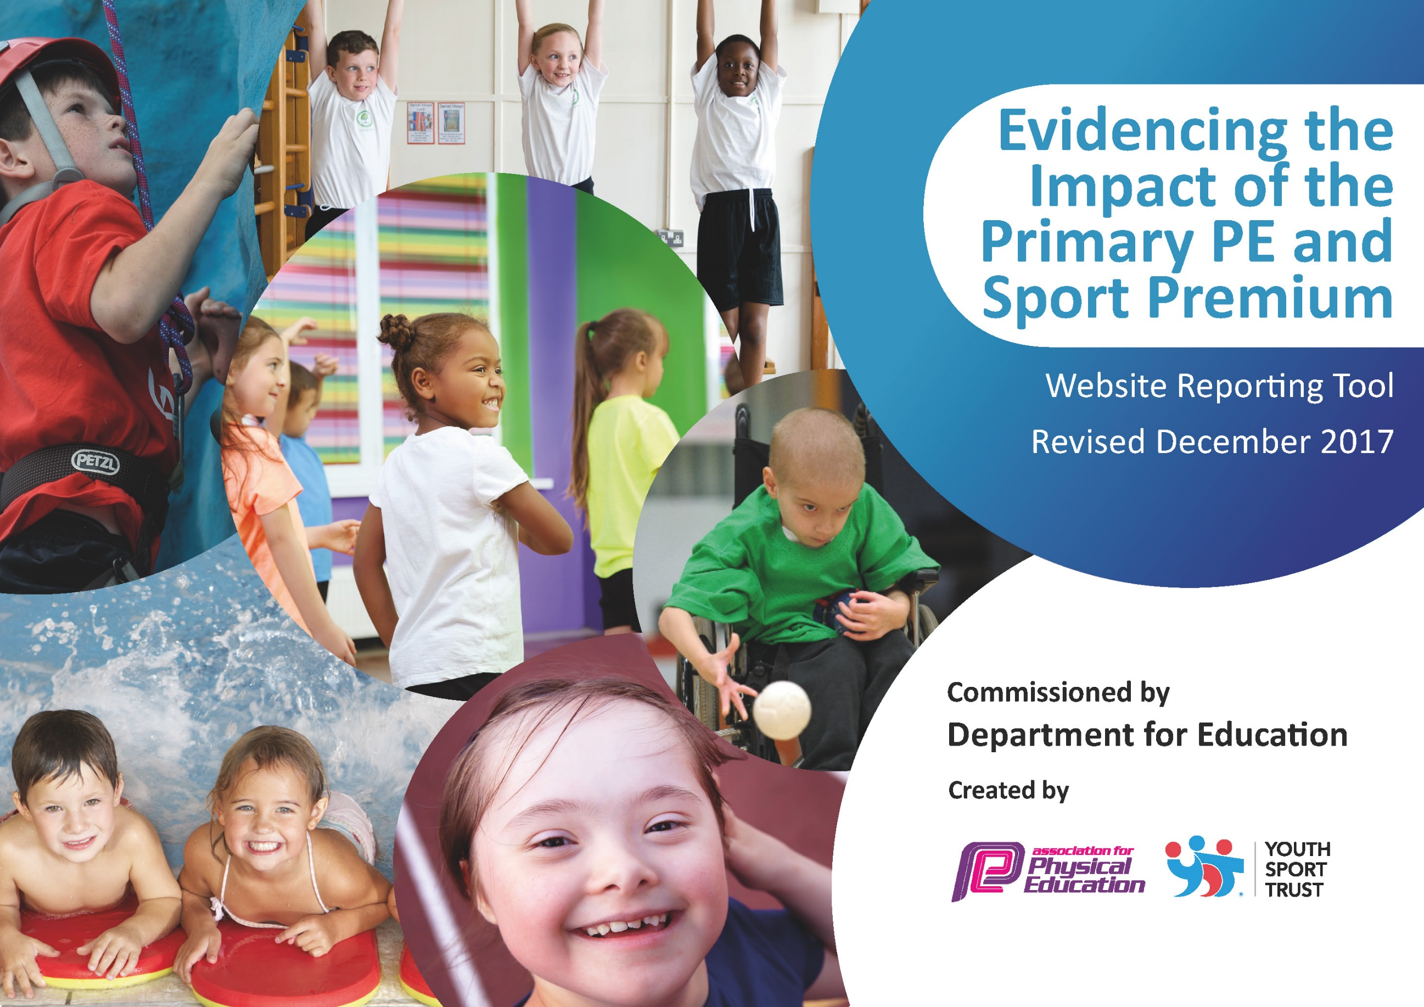

Schools must use the funding to make additional and sustainable improvements to the quality of PE and sport they offer. This means that you should use the Primary PE and Sport Premium to:

- develop or add to the PE and sport activities that your school already offers
- build capacity and capability within the school to ensure that improvements made now will benefit pupils joining the school in future years

Please visit gov.uk for the revised DfE guidance including the 5 key indicators across which schools should demonstrate an improvement. This document will help you to review your provision and to report your spend. DfE encourages schools to use this template as an effective way of meeting the reporting requirements of the Primary PE and Sport Premium.

We recommend you start by reflecting on the impact of current provision and reviewing the previous spend.
Under the Ofsted Schools Inspection Framework, inspectors will assess how effectively leaders use
the Primary PE and Sport Premium and measure its impact on outcomes for pupils, and how effectively governors hold them to account
for this.

Schools are required to publish details of how they spend this funding as well as on the impact it has on pupils’ PE
and sport participation and attainment.
We recommend regularly updating the table and
publishing it on your website as evidence
of your ongoing review into how you are using the money
to secure maximum, sustainable impact. To see an example of how to complete the table please click HERE.

Support for review and reflection - considering the 5 key indicators from DfE, what development needs are a priority for your setting and your students now and why? Use the space below to reflect on previous spend, identify current need and priorities for the future.

Key achievements to date: | Areas for further improvement and baseline evidence of need:
- School Sport gold award (awarded for the 2019-2020 academic year)  - KS2 cycling finals  - Year 3/4 New Age Curling finals  - Year 5/6 tri golf finals  - Year 5/6 Tag rugby Crossbar cup winners  - Year5/6 TWSSP Football runners up | - Invest in more sport and playtime equipment (daily mile track)  - Continue to up level all staff’s confidence  - For all children to participate in intra-school competitive competitions  - To maintain School Sport gold award

Meeting national curriculum requirements for swimming and water safety | Please complete all of the below*:
What percentage of your current Year 6 cohort swim competently, confidently and proficiently over a distance of at least 25 metres? | 20%
What percentage of your current Year 6 cohort use a range of strokes effectively [for example, front crawl, backstroke and breaststroke]? | 20%
What percentage of your current Year 6 cohort perform safe self-rescue in different water-based situations? | 10%
Schools can choose to use the Primary PE and Sport Premium to provide additional provision for swimming but this must be for activity over and above the national curriculum requirements. Have you used it in this way? | no

Action Plan and Budget Tracking
Capture your intended annual spend against the 5 key indicators. Clarify the success criteria and evidence of impact that you intend to measure to evaluate for students today and for the future.

Academic Year: 2021/22 | Total fund allocated: £19,240 | Date Updated: September 2021
Key indicator 1: The engagement of all pupils in regular physical activity – Chief Medical Officer guidelines recommend that primary school children undertake at least 30 minutes of physical activity a day in school |  |  |  | Percentage of total allocation:
 |  |  |  | 28%
School focus with clarity on intended impact on pupils: | Actions to achieve: | Funding allocated: | Evidence and impact: | Sustainability and suggested next steps:
To increase the engagement of all pupils in physical activity daily during lunchtime, break times and afterschool in a variety of different sports. | Variety of play time equipment  Playground activity daily rotations  After school clubs  Participate in the daily mile – Daily mile track to be constructed. | £500  (playground equipment)  £31,000 (October 2021) – Funded by SP | More children want to participate in the change for life activities and are enjoying their lunchtime activities  A range of sporting activities and active playground games can be observed across all age ranges  Majority of sporting clubs are used effectively by a range of pupils  Clubs are both for participation and training for competitions  Year groups participating in after school clubs every half term | Children will lead as change for life champions.  Use the skills of the staff to provide after school activities and clubs.
Key indicator 2: The profile of PE and sport being raised across the school as a tool for whole school improvement |  |  |  | Percentage of total allocation:
 |  |  |  | 64%
School focus with clarity on intended impact on pupils: | Actions to achieve: | Funding allocated: | Evidence and impact: | Sustainability and suggested next steps:
To promote lifelong love of sport and the benefits of why we participate in sport. | Arthog Outreach  Crossbar | £2000  (Arthog Outreach)  £27,000  (Crossbar) | Arthog Outreach will be delivering a range of outdoor activities to years 3 and 5 (canoeing, rock climbing)  Crossbar will raise the profile of PE across the whole school in a variety of ways;  - Training for staff  - High quality PE lessons  - Promote physical activity during lunchtime  - Deliver after school clubs  - Run holiday clubs  - Promote the importance of a healthier lifestyle | Playtimes will be more active with older children encouraging and supporting others in participating in physical activities using resources such as Change for Life  A broad range of resources will encourage children to want to participate in physical activity at various times throughout the school day.

Key indicator 3: Increased confidence, knowledge and skills of all staff in teaching PE and sport |  |  |  | Percentage of total allocation:
 |  |  |  | 7%
School focus with clarity on intended  impact on pupils: | Actions to achieve: | Funding  allocated: | Evidence and impact: | Sustainability and suggested  next steps:
Children will receive higher quality of PE as a result of staff who are now confident, skillful and knowledgeable on the subject of PE.  Provide lesson plans for staff for each area of PE. | Courses for staff:  -H5 Netball development sessions.  -NQT PE CPD  -KS1 Gymnastics CPD  -PE Subject Leader Day Conference  -Inclusive PE CPD  -OAA CPD | Annual subscription to the School Sports Partnership  £2500 | Monitoring of lessons
 | Release time for less confident members of staff to observe high quality PE teaching taught by crossbar. | Crossbar | Monitoring of lessons | Staff feel more confident with the teaching of PE for their age range.
 | Ensure equipment is available and ready to teach each area of PE. | £1000 | Monitoring of lessons | Audit and order equipment needed.
Key indicator 4: Broader experience of a range of sports and activities offered to all pupils |  |  |  | Percentage of total allocation:
 |  |  |  | 1%
School focus with clarity on intended  impact on pupils: | Actions to achieve: | Funding  allocated: | Evidence and impact: | Sustainability and suggested  next steps:
To provide children with additional sporting opportunities that make links with the local community.  To provide a wider range of curricular and extra-curricular sporting activities. | Links with local sports clubs (addressing the medical officer guidelines)  A chance to professional tennis players at Shrewsbury tennis club. | NA | Children are now playing for local teams in:  Football  Gym  Karate  Dance  Cheerleading | The children’s skills will continue to develop not only through the school curriculum but in these clubs, therefore allowing more children to be active.
 | Arthog  Arthog Outdoor centre | Listed previously | Built confidence in the children’s skills and developed their communication, teamwork and problem solving skills which were  then transferred into the school and residential environment. | Children will be acquiring lifelong skills.
 | PE equipment:  Order PE equipment for the delivery of;  Handball  Netball  Tag rugby  Kwik cricket  Athletics | (Already listed above)  £1500 | Teachers are able to deliver higher quality of lessons due to having a wider range of resources and enough resources for the class. | The equipment will be used to enhance the teaching of PE and provide the children with a range of activities
 | Competitions to include inclusive competitions ensuring that all children have the opportunity to be involved and compete in sport | Listed previously | SEN children in ks2 will have the opportunity to participate in the majority of competitive sporting events. | Continue to allow all children in the school to participate and compete in a competitive environment
 | Sports clubs/ holiday clubs - Crossbar | Listed previously | Children remain active during the holidays. | Sustainable as cost is met by parents
Key indicator 5: Increased participation in competitive sport |  |  |  | Percentage of total allocation:
 |  |  |  | %
School focus with clarity on intended  impact on pupils: | Actions to achieve: | Funding  allocated: | Evidence and impact: | Sustainability and suggested  next steps:
To enter multiple teams into a variety of competitions allowing more children to apply their skills into a competitive fixture and develop their love for sport. | - Year 3&4 boys football league  - Years 5&6 girls football league  - Years 5&6 boys football league  - Cross bar cup -Football  - Cross bar cup – Tag Rugby  - Tag rugby  - Netball  - Cross country  - Sports hall athletics  - Intra-school competitions – delivered at the end of each unit | Listed previously  Free | 100% of children participate in inter house competitions which allows them to experience competitive sports and team work in a safe supported environment | Continue to enter a range of competitions where possible whilst following guidelines.

