Reading
Autumn 1 |  | Autumn 2 | Spring 1 | Spring 2 | Summer 1 | Summer 2
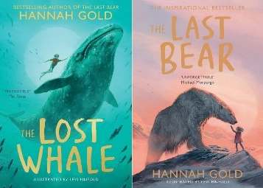  The Last Bear by Hannah Gold |  | 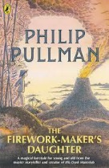  The Firework Maker’s Daughter by Phillip Pullman | 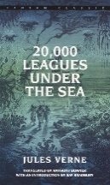  20000 Leagues Under The Sea by Jules Verne | 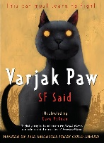  Varjak Paw by S F Said | 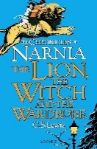  The Lion, Witch and the Wardrobe by C S Lewis | 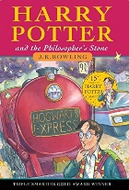  Harry Potter and the Philosopher’s Stone by J K Rowling
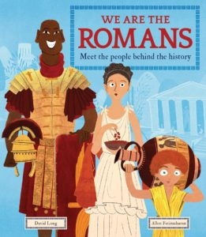  Romans (Non Fiction) |  | 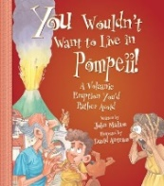  You wouldn’t want to live in Pompeii (Non Fiction) | 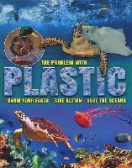  The problem with plastic by Ruth Owen (Non Fiction) | 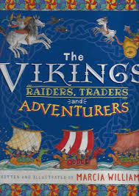  The Vikings, Raiders, Traders and Adventurers. (Non Fiction) | 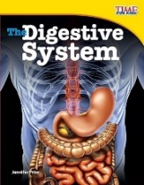  Digestive System (Non Fiction) | 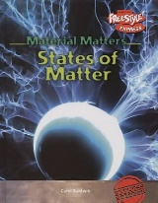  States of Matter (Non Fiction)
Writing
 | Autumn 1  Romans | Autumn 2  Volcanoes | Spring 1  Blue Abyss | Spring 2  Saxons and Vikings | Summer 1  Burps, bottom and bile | Summer 2  Potions
Quality Text/ Stimulus | Krindlekrax by Phillip Ridley  Roman Non Fiction Books  Poetry: The Works Year 4 | Escape to Pompeii by Christina Balit  Tuesday by David Wiesner  Poetry: The Works Year 4 | Malamander by Thomas Taylor  Extract: Fantastic Beasts by JK Rowling  Extract: Arthur Spiderwick’s by Holly Black  The problem with plastic by Ruth Owen | Arthur and the Golden Rope by Joe Todd-Stanton  Extract: Beowulf by Michael Morpurgo  The Vikings: Raiders, Traders and Adventurers! -Marcia Williams  Saxon and Viking Non Fiction Texts | Lion, Witch and the Wardrobe by C .S Lewis  Extract: The Last Bear by Hannah Gold | Harry Potter and the Philosopher’s Stone.  Extract: Alice in Wonderland  Poetry: The Works Year 4
Purpose for Writing  Text Type | To Inform  Non Chronological Report  To Entertain  Descriptive Writing: Thriller  To Entertain  Poetry: Limericks | To Entertain  Diary Entry  To Inform  Newspaper Report  To Entertain  Poetry: Metaphors | To Entertain  Narrative: Mystery thrilled Adventure  To Inform  Formal letter: Reducing Plastic Pollution | To Entertain  Myth  To Inform  Non-Chronological Report | To Entertain  Narrative: Fantasy  To Inform  Explanation: Digestive System | To Entertain  Narrative: Fantasy  To Persuade  Persuasive Leaflet  To Entertain  Poetry: Kennings
Oracy Projects | Perform Limericks | Christmas Performance  News Bulletin | Science Link: Human Impact on habitats. | Easter Performance  Perform Poems | Scientific Explanation  (Recorded) | Persuasive Advert (Recorded)
Performance Poetry |  |  | The Sea is a Hungry dog by James Reeves |  | The Dentist and the Crocodile by Roald Dahl | Song of the Witches by William Shakespeare
National / World Events  *Purposeful writing & speaking and listening opportunities | National Poetry Day  Black History Month |  | National Storytelling Week | International Women’s Day  World Book Day  World Storytelling & Poetry Day | World Day for Cultural Diversity | World Environment Day
Story Time Texts | 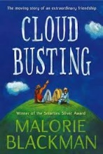  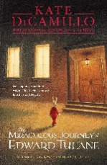  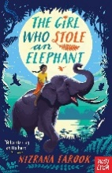  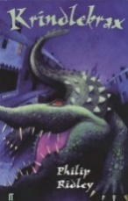  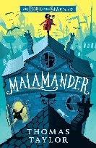
Poetry  Pie Corbett’s Year 4 Spine  Daily Poem | 