 | Memory Box  Weston Park | Street Detectives  Telford Tours | Superheroes  Freshwater Theatre  Florence Nightingale | Paws, Claws & Whiskers  Exotic Zoo | Dinosaur Planet  West Midlands Safari | Enchanted Woodland  Attingham Park
Writing | Autumn 1 | Autumn 2 | Spring 1 | Spring 2 | Summer 1 | Summer 2
Quality Text/  Stimulus | 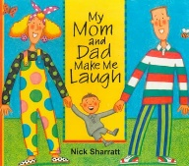  My mom and dad make me laugh by Nick Sharratt  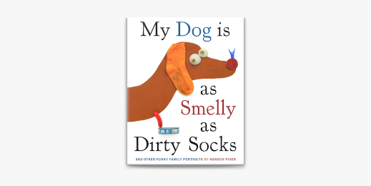  My dog is as smelly as dirty socks by Hanoch Piven  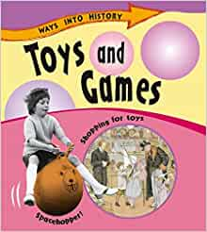  Toys from the past (Non Fiction texts) | 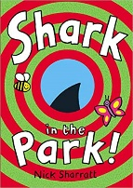  A Shark in the Park by Nick Sharatt  Local history stimuli  Captain Webb | 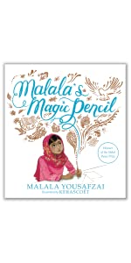  Malala’s Magic Pencil by Malala Yousafzi  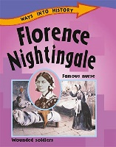  Florence Nightingale  (Non Fiction)  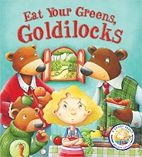  Linked to DT: Healthy Sandwich | 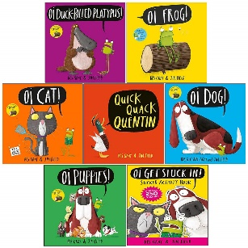  Author Study: Kes Gray  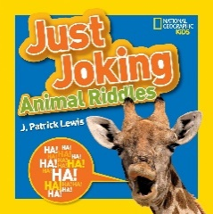  Just Joking Animal Riddles. (National Geographic)  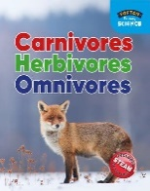  Animals (Non Fiction texts | 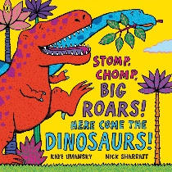  Stomp, chomp big roars, here come the dinosaurs by Kaye Umansky  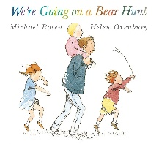  We’re going on a bear hunt by Michael Rosen | 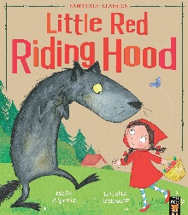  Little Red Riding Hood by Mara Alperin  Hansel and Gretel by Josephine Collins  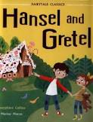
Purpose for Writing  Text Type | To Entertain  Mom and Dad Make Laugh  Character Description 1 wk  To Entertain  Dog is as smelly as socks  Poem using similes. 1 wk  Visit to Weston Park  To Inform  Recount Visit 1 wk  To Inform  Toys Old and New  Fact Files 1 wk | To Entertain  Shark in the Park  Narrative 1 wk  Visit on Telford Tours  To Inform  Recount Visit 1 wk  To Inform  Captain Webb  Fact Files 2wk | To Entertain  Malala’s Magic Pencil  Narrative 1 wk  Visit; Theatre  To Inform  Historical Recount  Diary of Florence 1 wk  To Inform  DT : Healthy Sandwiches  Instructions 1 wk | To Entertain  Kes Gray Oi Frog!  Narrative 1 wk  Visit Exotic Zoo  Poetry  Animal Riddles 1 wk  To Inform  Animals Fact Files 1 wk | To Entertain  We’re going on a…hunt Narrative 1 wk  Visit WMSP  To Inform  Recount Visit 1 wk  To Entertain  Stomp, Chomp, Roar!  Poems using onomatopoeia. 1 wk  To Inform  DT Pop Up Card  Instructions 1 wk | To Entertain  Little red Riding Hood  Retelling (2 wks)  Visit Attingham Park  To Inform  Recount Visit 1 wk  To Entertain  Narrative Hansel and Gretel Retelling  2 wks

Oracy Projects | Set up a toy museum.  Share knowledge on toys from the past. | National Poetry Day performances | Class Assembly | Perform riddles | Perform Poems | Perform AA Milne poem for website.

Performance Poetry | When Goldilocks went to the house of the bears.  This old man | The Alphabet Song  Mary had a little lamb | There was a crooked man  Little Bo Peep | There was an old lady who swallowed a fly  Sing and song of sixpence. | There’s a hole in the bottom of the sea.  Old Mother Hubbard | Now we are six by AA Milne

Story Time Texts  *Rich vocabulary development  *Emotional Literacy  *Diversity  *Inclusivity  *Environmental conservation  *Poetry | Paperdolls by Julia Donaldson  Owl Babies by Martin Waddell  Once they were Giants by Martin Waddell  Not now Bernard! by David McKee  This rabbit belongs to Emily Brown by Cressida Cowell  Lost in the toy museum by David Lucas  Old bear by Jane Hissey  Numenia and the Hurricane by Fiona Halliday PSED  The Growing Story by Ruth Krass  Baby Brains by Simon James  The Memory Tree by Britta Teckentrup  PSED  Toys in space by Mini Grey  Grandpa by John Burningham PSED  Mrs Armitage on wheels by Quentin Blake  No home for a ghost by Jess Rose Diversity  Kippers Toy Box by Mick Inkpen  Non Fiction  Families | The Jolly Postman or other peoples letters by Janet and Allan Ahlberg  Mrs Wobble the Waitress by Jane and Allan Ahlberg  The town mouse and the country mouse by Susanna Davidson  The Ironbridge Ogre by Toni Sian Williams  Last stop on market street by Matt de la pena  Diversity  The paperbag prince by Colin Thompson Environment and Sustainability  The tin forest by Helen Ward Environment and Sustainability  The voices in the park by Anthony Browne  The shopping basket by John Burningham  Shark in the dark by John Burningham  The dinosaurs that pooped Christmas by Tom Fletcher  Funnybones by Allan Ahlberg  I am too absolutely small for school by Lauren Child  Harry and the Christmas wish by Ian Whybrow  Oi get off my train by John Burningham  Non Fiction  Captain Webb Texts | Supertato by Sue Hendra  Superkid by Claire Freedman  Willy the wimp by Anthony Browne  Max by Bob Graham  Avacado Baby by John Burningham  Traction man is here by Mini Grey  Charlie superhero super pants by Paul Bright  Super Milly and super school day by Stephanie Clarkson  Superworm by Julia Donaldson  Pink is for boys by Robb Pearlman Diversity  How to catch a star by Oliver Jeffers  Lost and Found by Oliver Jeffers PSED  Beegu by Alexis Deacon  The Girls by Lauren Ace Diversity  Non Fiction  Superhero  National heroes  International heroes | The Lion Inside by Rachel Bright  The elephant and the bad baby by Elfrida Vipont  A lion in the meadow by Margaret Mahy  Cinnamon by Neil Gaiman Diversity  Kaya’s heart song by Diwa Tharan Sanders Diversity  The tiger who came for tea by Judith Kerr  Alans Big Scary Teeth by Jarvis  Giraffe Problems by Jory John  How to wash a woolly mammoth by Michelle Robinson  The Ugly Five by Julia Donaldson  Meerkat Mail by Emily Gravett  Kes Gray Book Collection  The Mixed up Chameleon by Eric Carle  The Very Busy Spider by Eric Carle  If you’re happy and you know it by Jan Ormenod  Open Very Carefully by Nicola O Byrne  Non Fiction  Animal Texts | Where the Wild Things Are (Maurice Sendak)  Mad about Dinosaurs by Giles Andreae  Tyrannosaurus drip by Julie Donaldson Anti Bullying  Ruby’s Worry by Tom Percival PSED  Harry and the bucketful of dinosaurs by Ian Whybrow  Harry and the dinosaurs go to school by Ian Whybrow  Miles Kelly Collection x 6  Hey You! By Dapo Adeola Diversity  The dinosaur that pooped a princess by Tom Fletcher  Dinosaurs love underpants by Claire Freedman  The Vanishing Rainforest by Richard Platt Environment and Sustainability  Dear Greenpeace by Simon James  Environment and Sustainability  Mad about Dinosaurs by Giles Andreae  Achoo! By Simon Phillip Where the wild things are by Maurice Sendak  Julien at the Wedding by Jessica Love Diversity  Non Fiction  Dinosaurs Texts | Gruffalo by Julia Donaldson  The bad tempered ladybird by Eric Carle  Can’t you sleep little bear by Martin Waddell  Hansel and Gretel First Fairy Tales  Peace at last by Jill Murphy  The cat in the hat by Dr Seuss  The Gingerbread Man by Mirimam Latimar  The Grumpy Fairies by Bethan Stevens Diversity  Little red Riding duck  Trust me! Jack’s beanstalk stinks!  Goldilocks and the three bears by Mara Alperin  Goldilocks and the three bears Usborne Pictures  If I were the world by Mar Sperring Environment and Sustainability  The Gruffalos Child by Julia Donaldson  Where the forest meets the sea by Jeannie Baker  Jack and the beanstalk First Fairy Tales  Three Little wolves and the big bad pig by Eugene Trivizas  The squirrels that squabbled by Rachel Bright  Non Fiction  Plants and Flowers Texts
Poetry Spine  Pie Corbett’s  Poetry Spine  Year 1  Daily Poem | 