AUTUMN 1 | AUTUMN 2 |  | Spring 1 |  | Spring 2 |  | SUMMER 1 |  | Summer 2
All about me | Celebrations |  | Transport & Journeys |  | Farming |  | In the Garden |  | Fairy Tales & Nursery rhymes
With support, I can listen to longer stories and can remember much of what happens.  I can engage in story times.  I can engage in non-fiction  With support I can talk about familiar books.  I am beginning to remember and sing entire songs.  I can use large-muscle movements to e.g. wave flags, paint and make | With support I know and understand a few of the key concepts about print: print can have different purposes, we read English text from left to right and from top to bottom  I know and can remember entire songs that I can sing.  I can listen to longer stories and can remember much of what happens.  I can talk about familiar books and be able to tell you a simple short story.  I know a wider range of vocabulary.  I can use longer sentences of four to six words.  I am developing my phonological awareness so I can; count and clap syllables and recognise words with the same initial sound, e.g. money / mother.  I can use one-handed tools and equipment, e.g., making snips in paper with scissors.  Use a comfortable grip with good control when using pens and pencils. |  | With support I know and understand a few of the key concepts about print: print can have different purposes, we read English text from left to right and from top to bottom  I know and can remember entire songs that I can sing.  I can listen to longer stories and can remember much of what happens.  I can talk about familiar books and be able to tell you a simple short story.  I know a wider range of vocabulary.  I can use longer sentences of four to six words.  I am developing my phonological awareness so I can; count and clap syllables and recognise words with the same initial sound, e.g. money / mother.  I can use one-handed tools and equipment, e.g., making snips in paper with scissors.  Use a comfortable grip with good control when using pens and pencils. |  | With support I know and understand a few of the key concepts about print: we read English text from left to right and from top to bottom, the names of the different parts of a book, for example, title author, front cover.  I can listen to longer stories and can remember much of what happens.  I know many rhymes and can to talk about familiar books and I can to tell you a long story.  I can engage in extended conversations about stories, learning new vocabulary.  I am developing my phonological awareness so I can; spot and suggest rhymes, count and clap syllables and recognise words with the same initial sound, e.g. money / mother.  I can use a comfortable grip with good control when using pens and pencils. I can use some print and letter knowledge in early writing. For example: writing a pretend shopping list that starts at the top of the page; write ‘m’ for mummy.  Develop communication; may continue to have problems with irregular tenses and plurals. |  | I know where the title of a story is  I know many rhymes and can to talk about familiar books and I can to tell you a long story.  I can engage in extended conversations about stories, learning new vocabulary.  I am developing my phonological awareness so I can; spot and suggest rhymes, count and clap syllables and recognise words with the same initial sound, e.g. money / mother.  I can associate some letters with phonological sounds.  With support I can use a comfortable grip with good control when using pens and pencils. I am showing a preference for a dominant hand.  I can use some print and letter knowledge in early writing. For example: writing a pretend shopping list that starts at the top of the page; write ‘m’ for mummy.  I know how to write some letters accurately, with support.  Develop communication; may continue to have problems with irregular tenses and plurals. |  | Understand the five key concepts about print: 1. Print has meaning 2. Print can have different purposes 3. We read English text from left to right and from top to bottom 4. The names of the different parts of a book 5. Page sequencing  Develop their phonological  awareness, so that they can:  - spot and suggest rhymes  - count or clap syllables in a  word  - recognise words with the  same initial sound, such as  money and mother  Targeted daily phonics sessions to teach rhyme, clapping syllables and recognising initial sounds in words.  Engage in extended conversations about stories, learning new vocabulary.  Use some of their print and letter knowledge in their early writing. For example: writing a pretend shopping list that starts at the top of the page; write ‘m’ for mummy.  Write some or all of their name.  I know how to write some letters accurately, with support.
Key Vocabulary:  Songs, nursery rhymes, stories, books, making marks, drawing. | Key Vocabulary:  Songs, nursery rhymes, stories, books, making marks, drawing. |  | Key Vocabulary:  Songs, nursery rhymes, stories, books, drawing. |  | Key Vocabulary:  Songs, nursery rhymes, books, stories, pictures, drawing |  | Key Vocabulary:  Songs, nursery rhymes, stories, books, drawing. |  | Key Vocabulary:  Songs, nursery rhymes, books, stories, pictures, drawing, writing.
Quality Texts
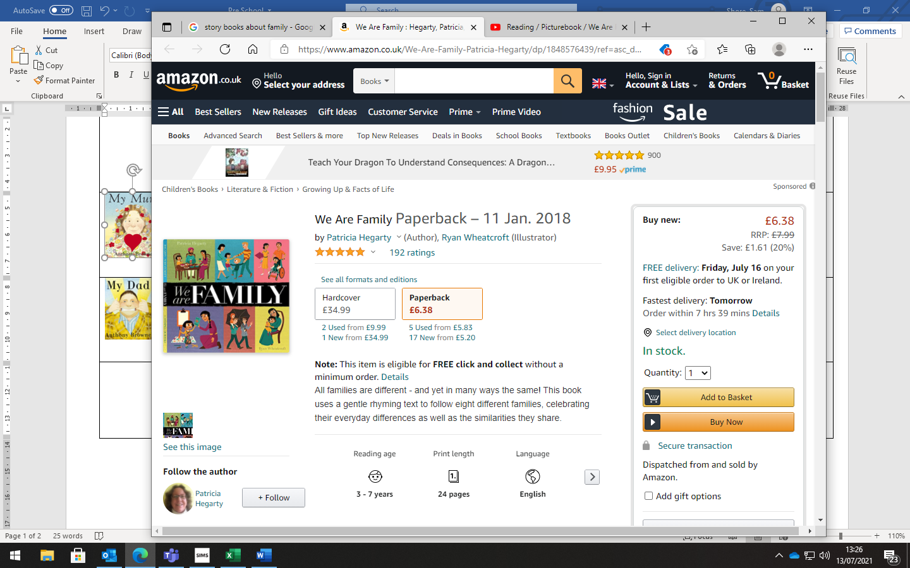  Mark Making-  Drawing pictures of families and adding meanings to marks (labelling) | 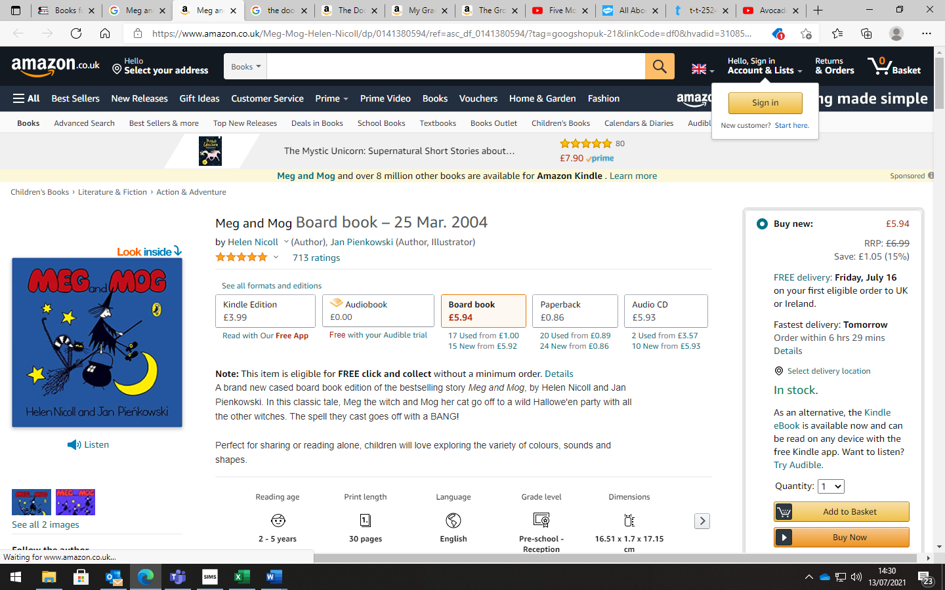  Mark making – writing spells. Creating a list of ingredients for potions. |  | 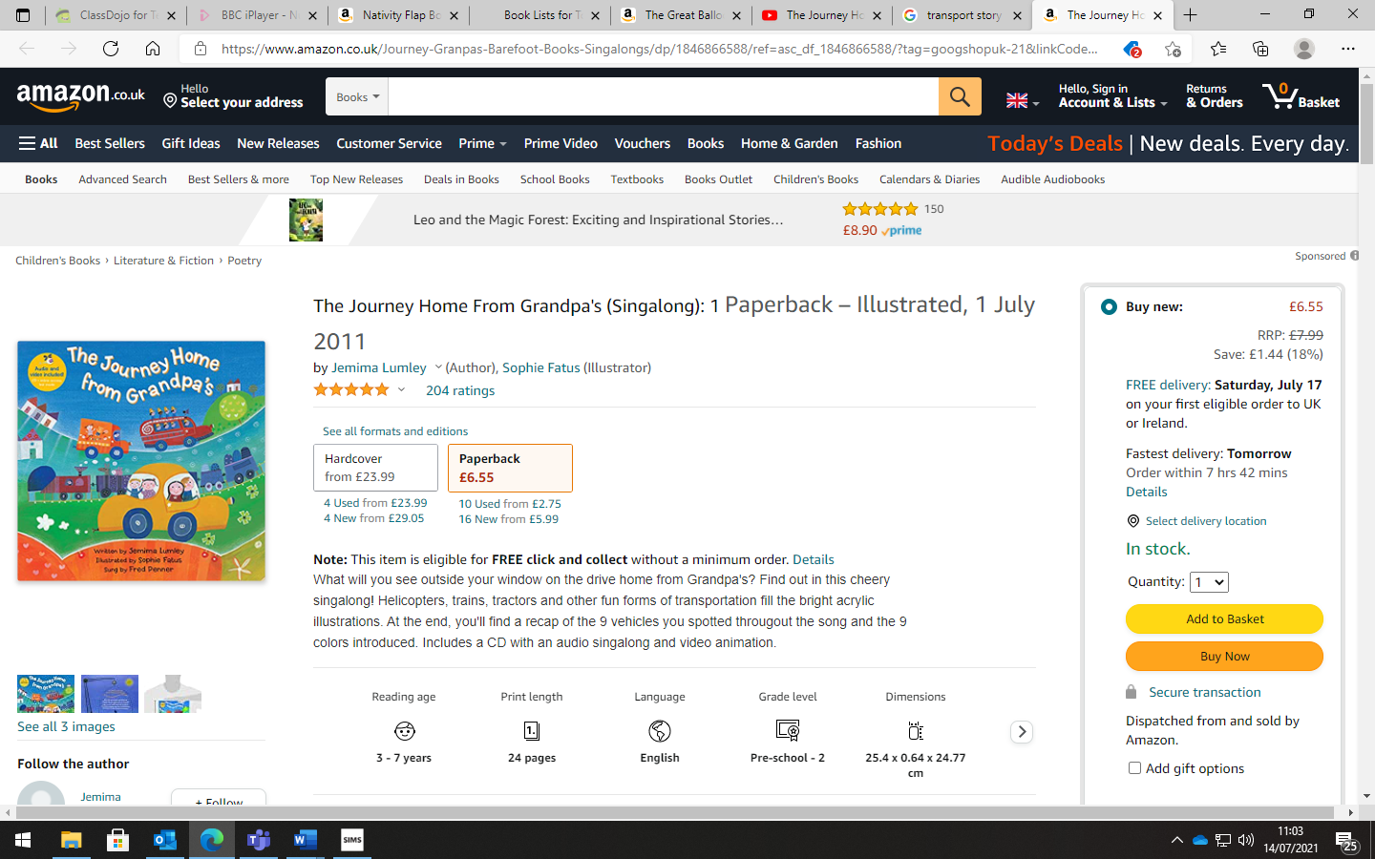  Mark making – Giving meaning to marks – drawing pictures of the different modes of transport. |  | 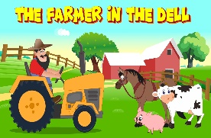  Role play – creating shopping lists for the farm shop. |  | 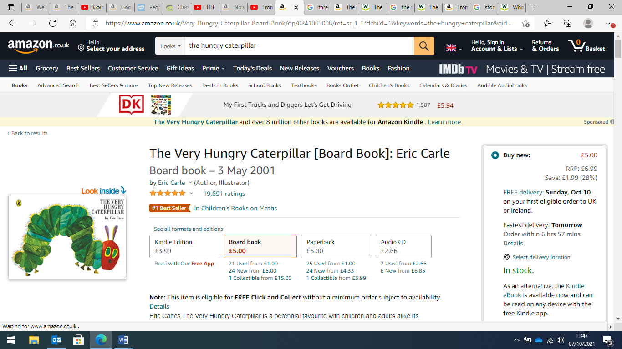  Role play - Mark making – creating shopping list for the supermarket. |  | 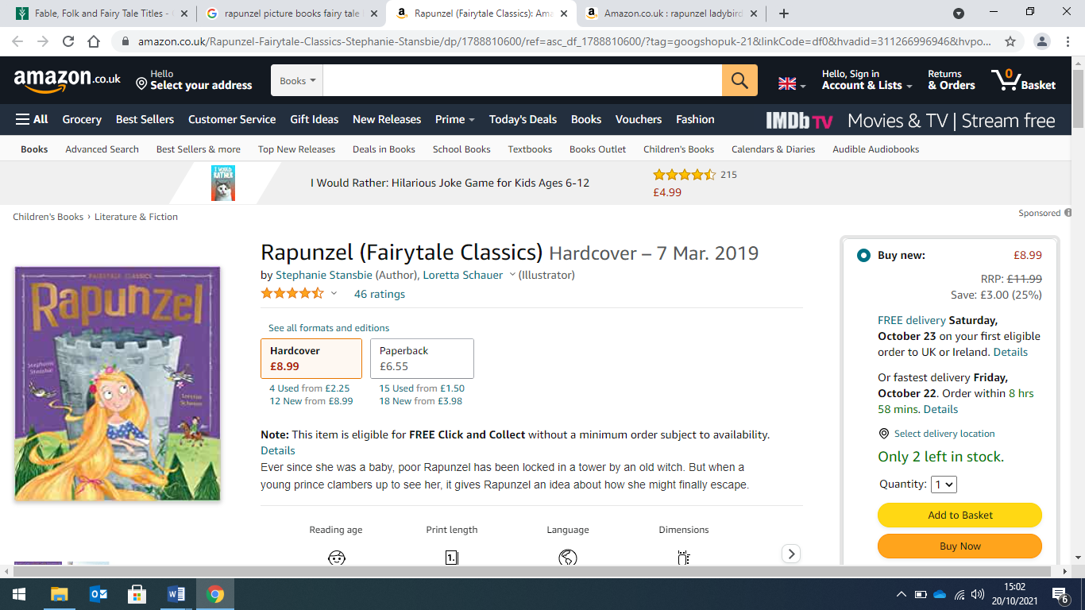  Mark making – Giving meaning to marks – draw Rapunzel’s tower and add initial sounds to its features.
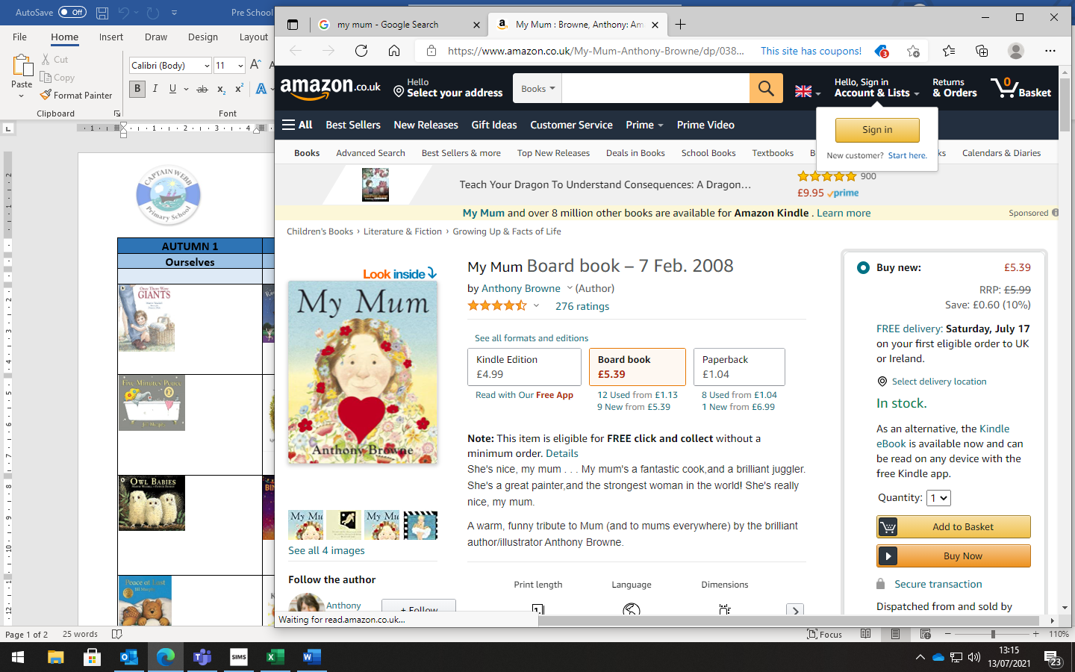  Mark Making – creating pictures of mum and adding meaning to marks they make. | 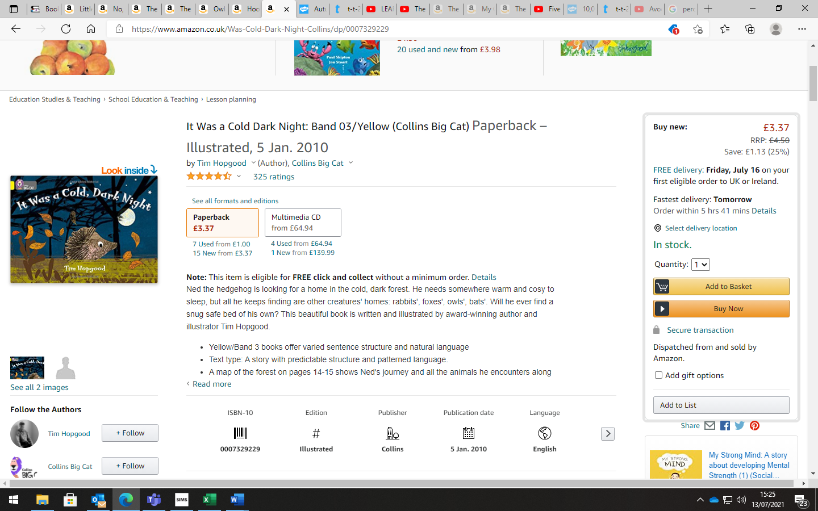  Mark making – children to use chalks to create fireworks patterns - using spirals, lines etc |  | 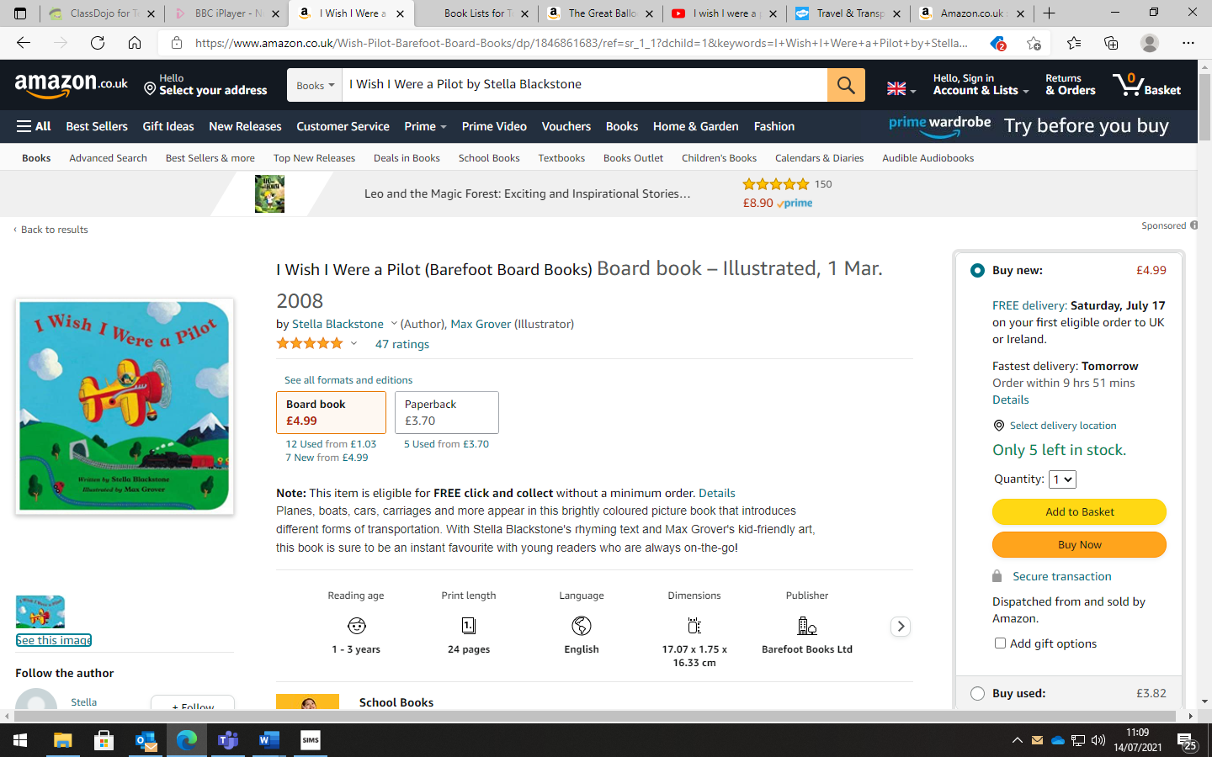  Mark making – Giving meaning to marks – drawing pictures of their favourite mode of transport. |  | 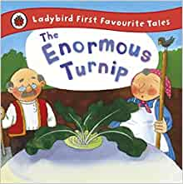  Mark making – Giving meaning to marks – draw the characters from the story and label them. |  | 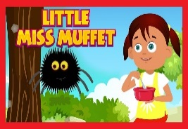  Giving meaning to marks – creating a set of instructions for making porridge. |  | 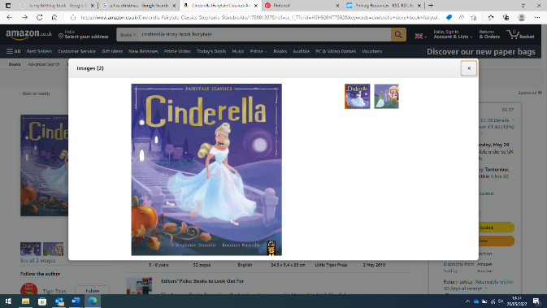  Mark making – create their own party invitation and try writing their own name or initial sound of their name.
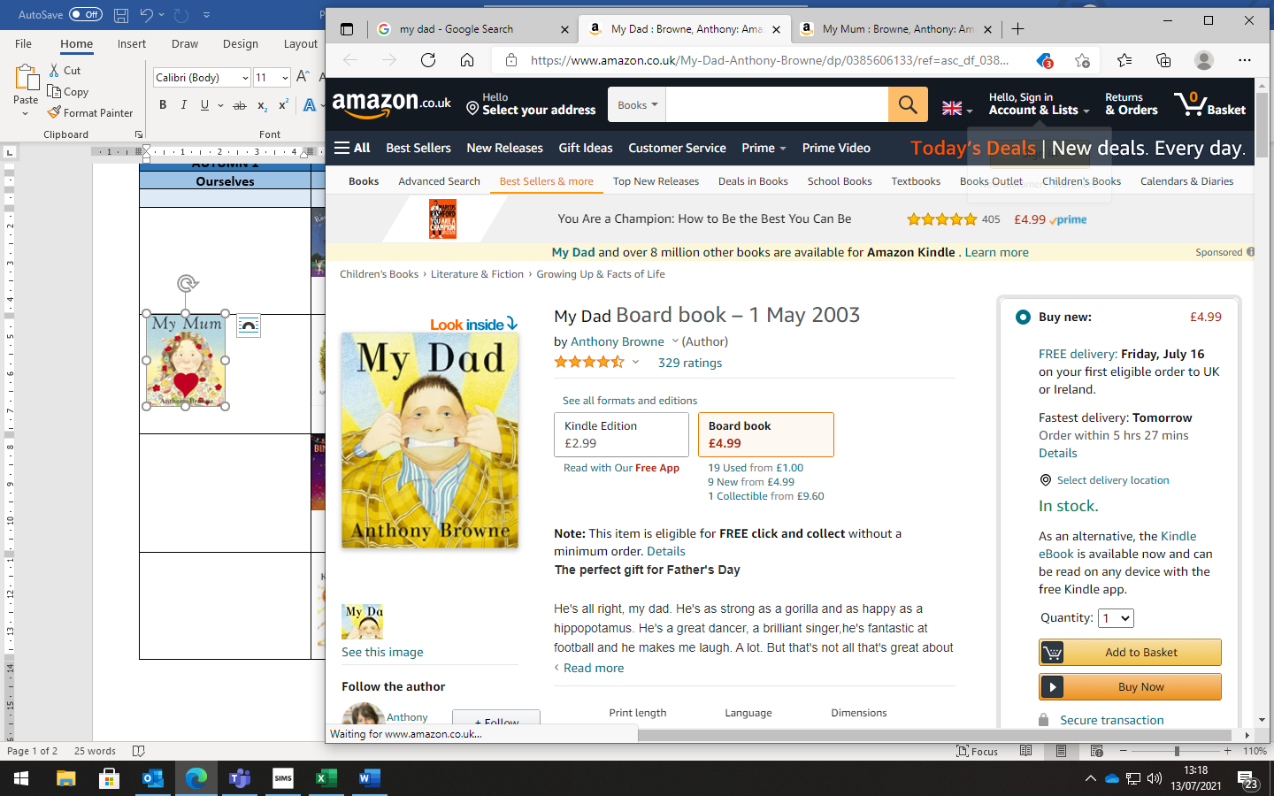  Enclosing a space – Giving meaning to marks - drawing a house. | 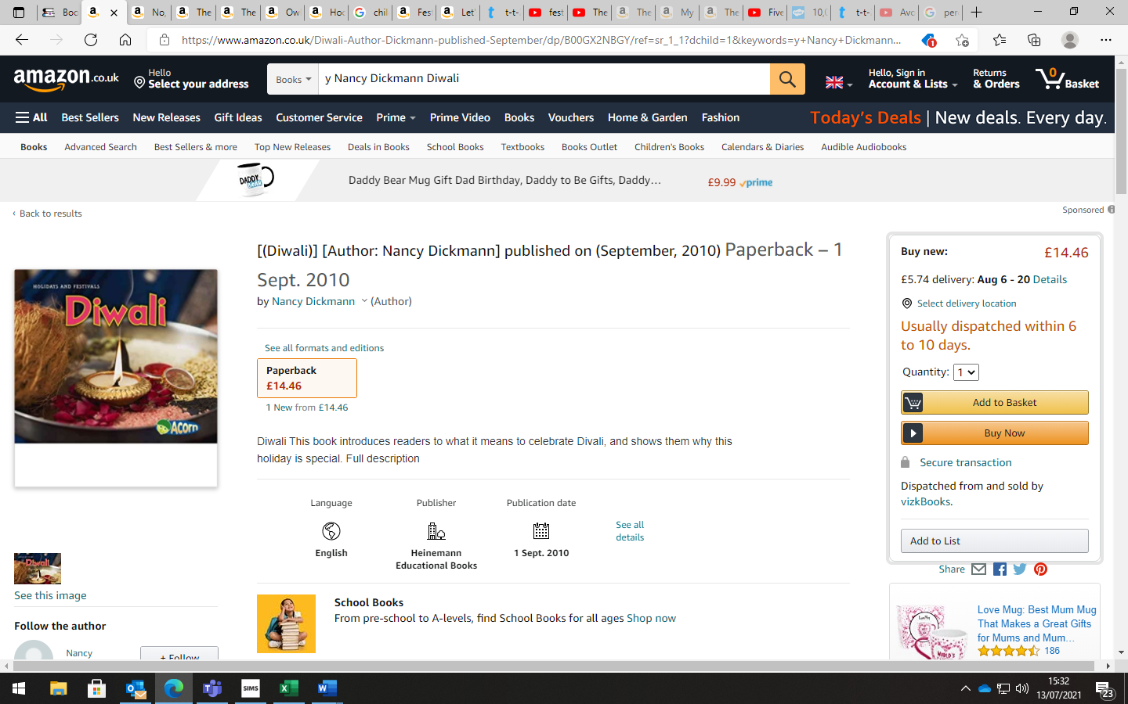  Mark making – children to create instructions for making a Diva lamp. |  | 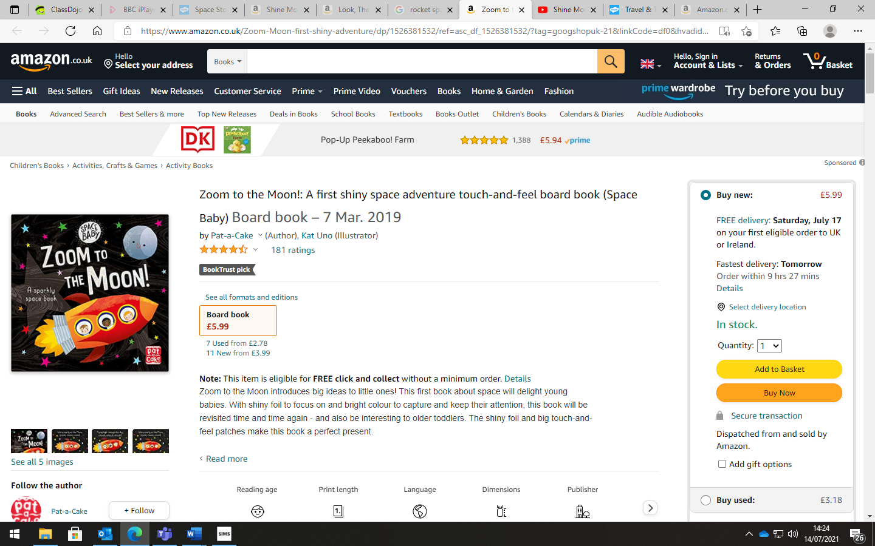  Mark making – create a set of instructions on how to build a rocket. |  | 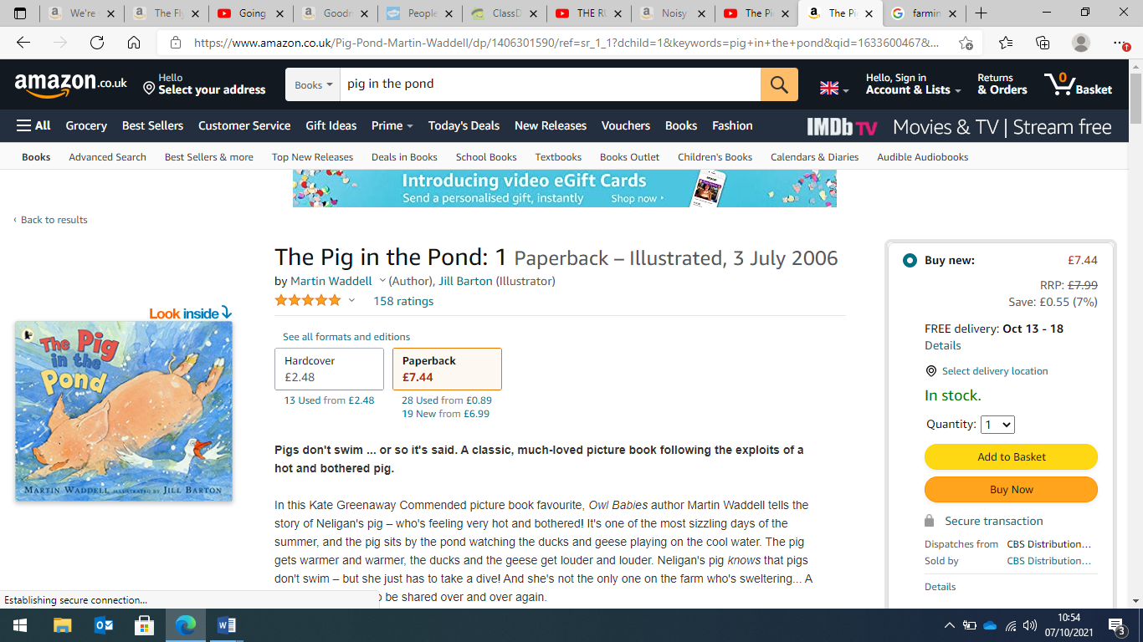  Giving meaning to marks – Create a list of animals on the farm and record how many there are of each. |  | 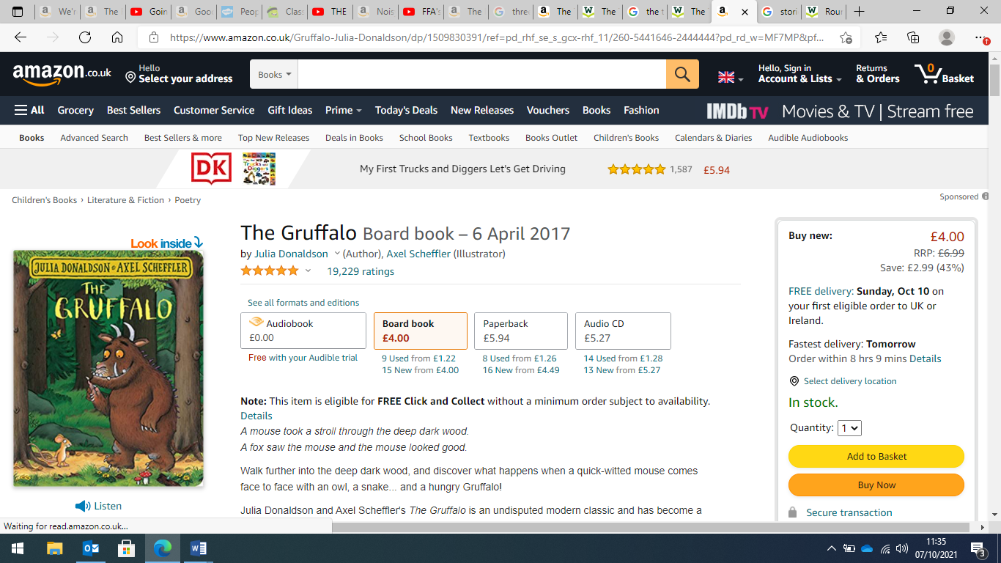  Mark making – Giving meaning to marks - draw their favourite characters from the story and describing what they have drawn. |  | 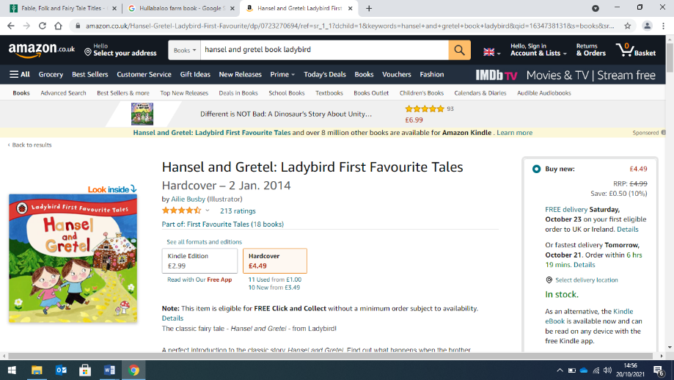  Mark making – create a set of instructions for creating a biscuit house.
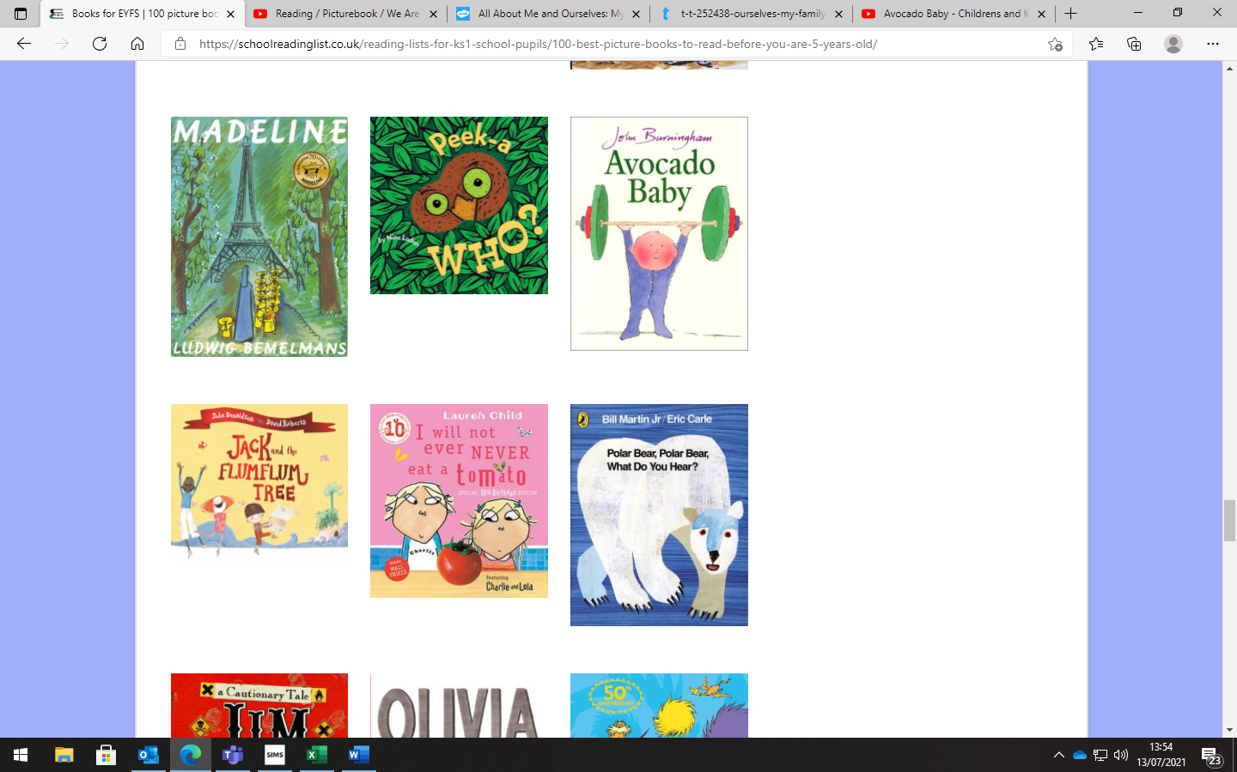  Give meaning to marks – creating a list of healthy food.  Role play – baby clinic pretending to record babies statistics. | 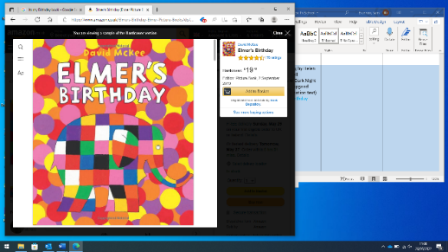  Mark making – Giving meaning to marks – to make invitations to go to Elmer’s party. |  | 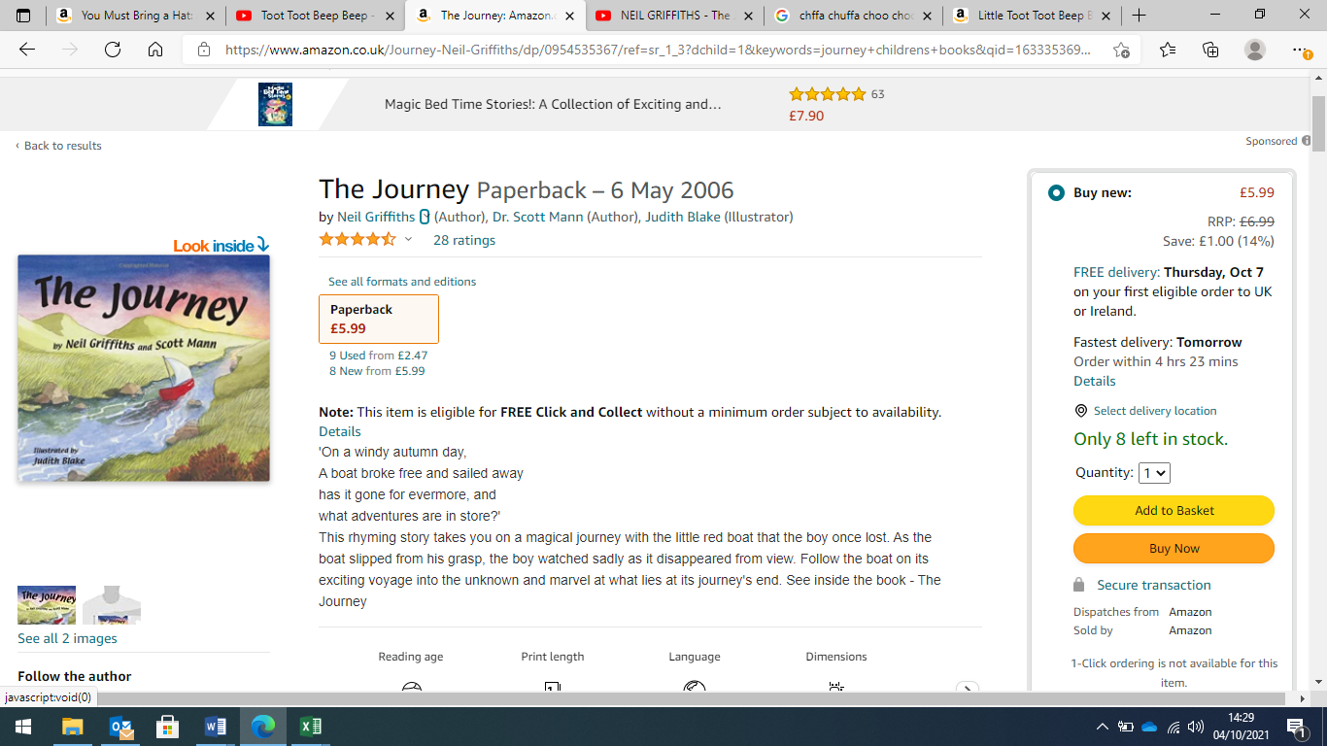  Role play - Mark making – creating tickets for passengers.  Making list of things they will be packing. |  | 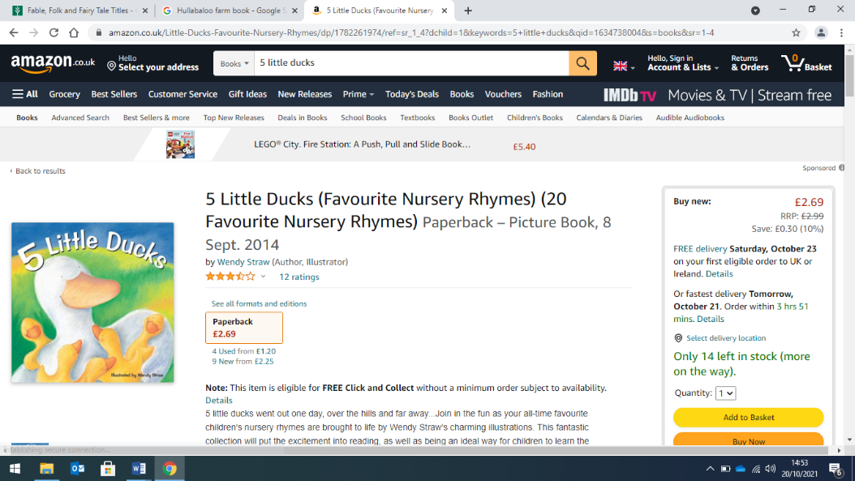  Giving meaning to marks – Create a visual diary of the eggs hatching. |  | 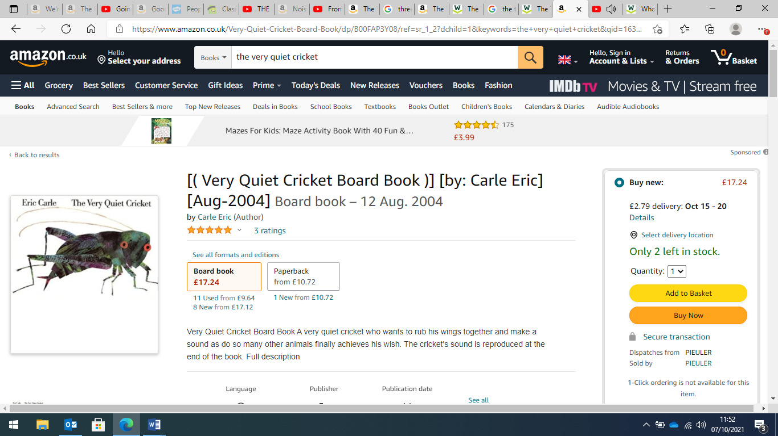  Mark making – Draw favourite character and try to write the initial sound using sound mats. |  | 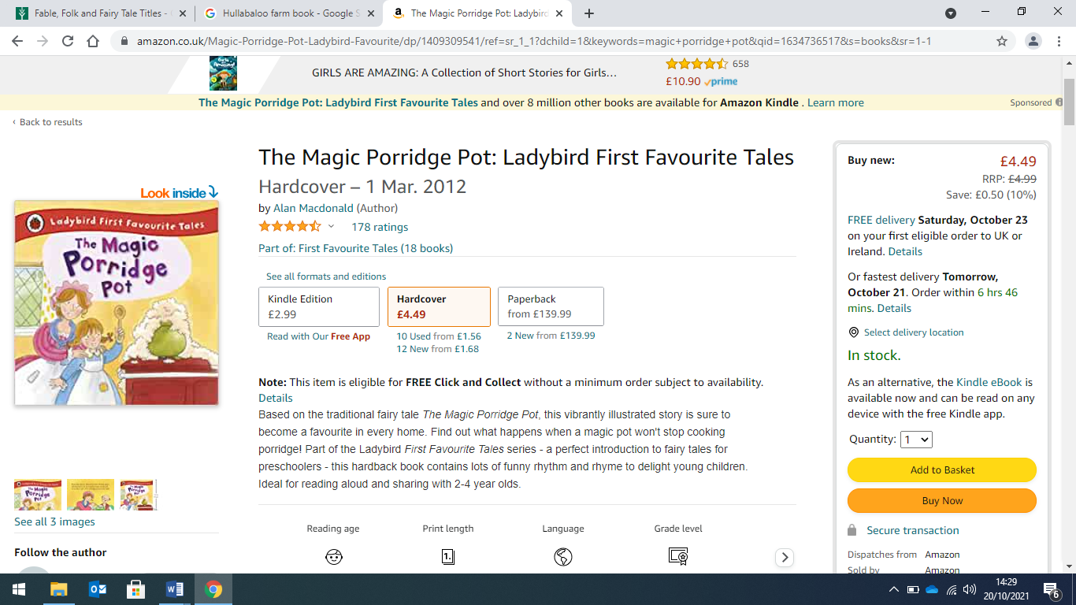  Mark making – giving meaning to marks – Create their magic spell for the porridge pot.
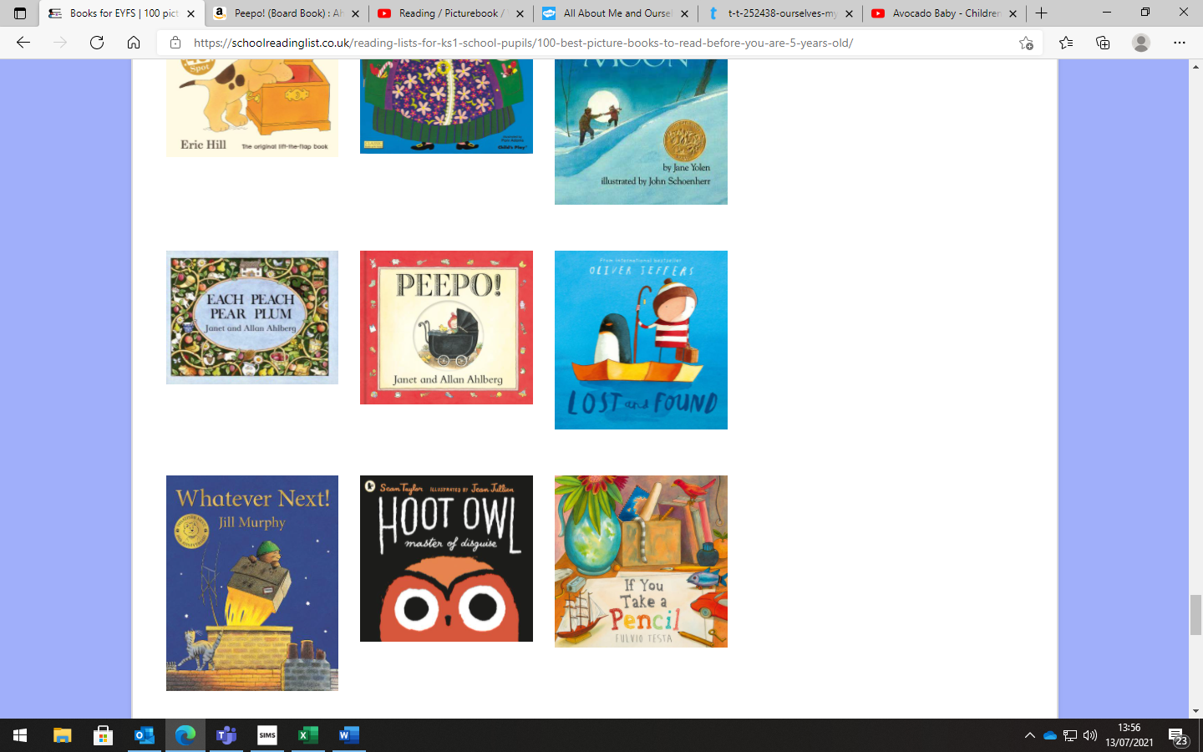  Role play – baby clinic pretending to record medical information. | 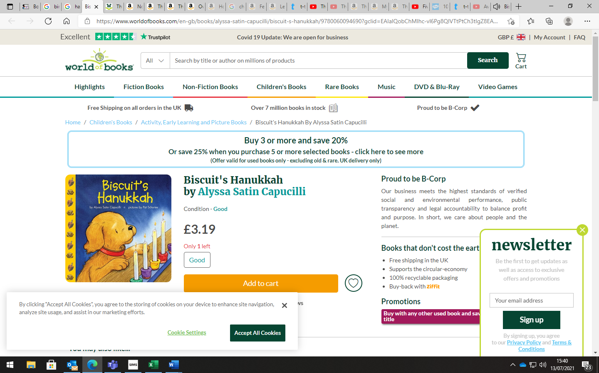  Role play – creating shopping lists for a party.  Mark making – Giving meaning to marks – writing thankyou notes for presents. |  | 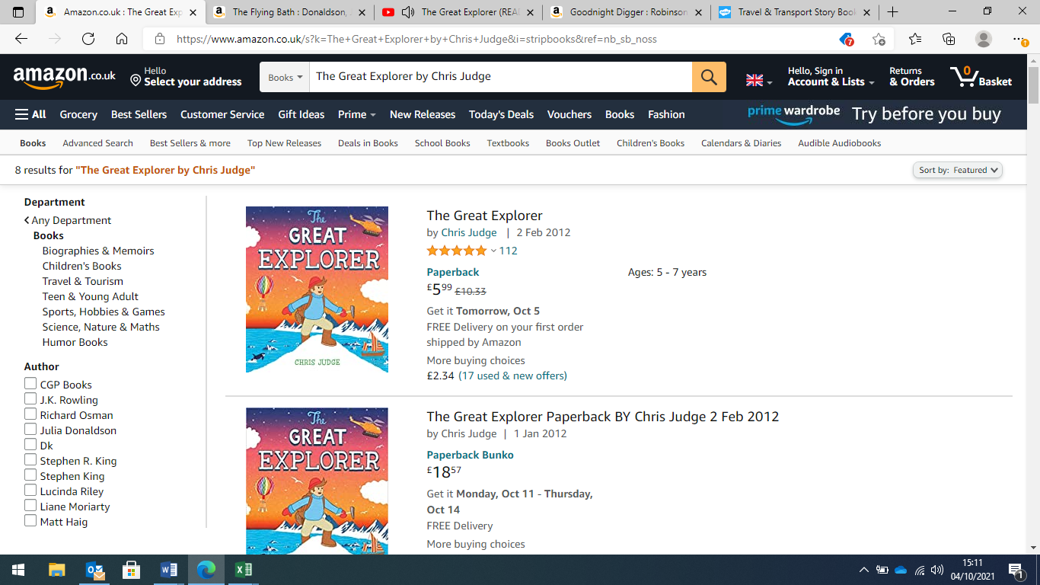  Mark making – creating a map for their journey.  Giving meaning to marks - Drawing pictures of what they see on their journey. |  | 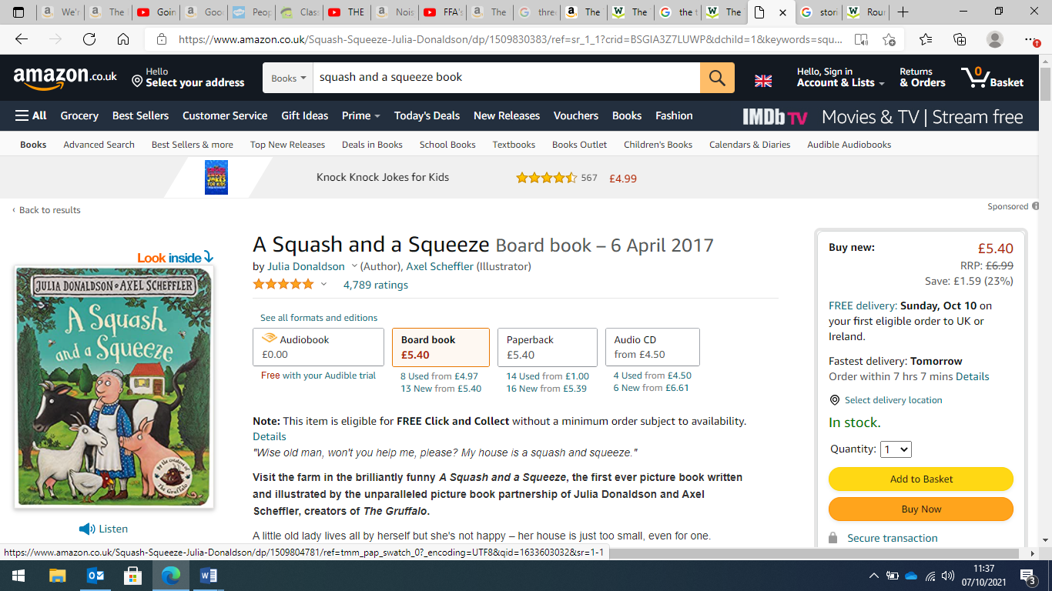  Giving meaning to marks – create a list of all the animals in the old lady’s house. |  | 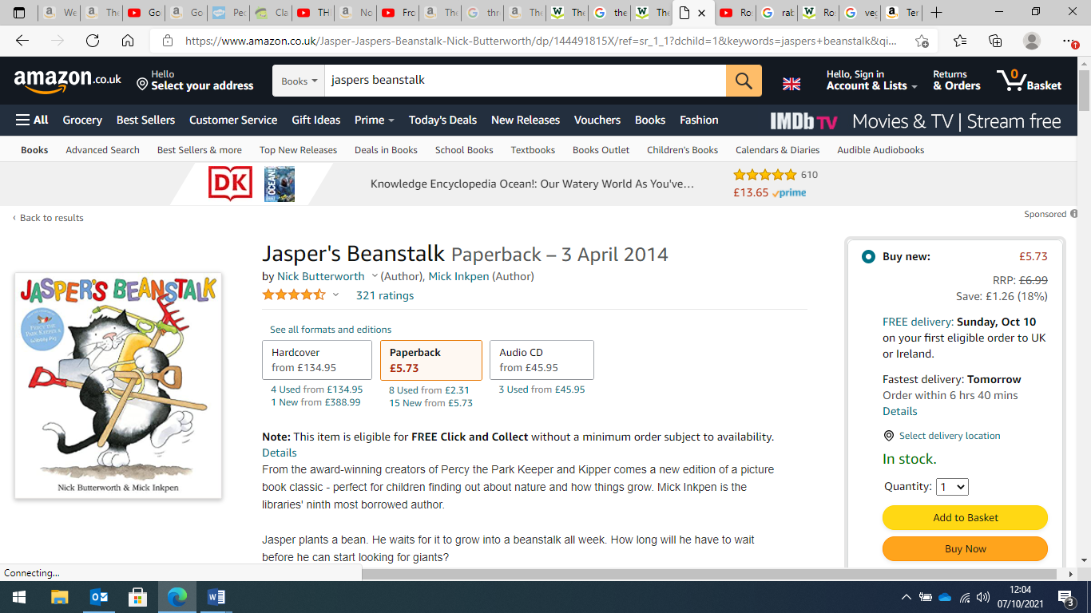  Mark making – Giving meaning to marks – create a set of instructions for planting a bean. |  | 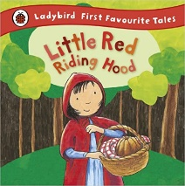  Mark making – giving meaning to marks – create a get well card for Grandma.
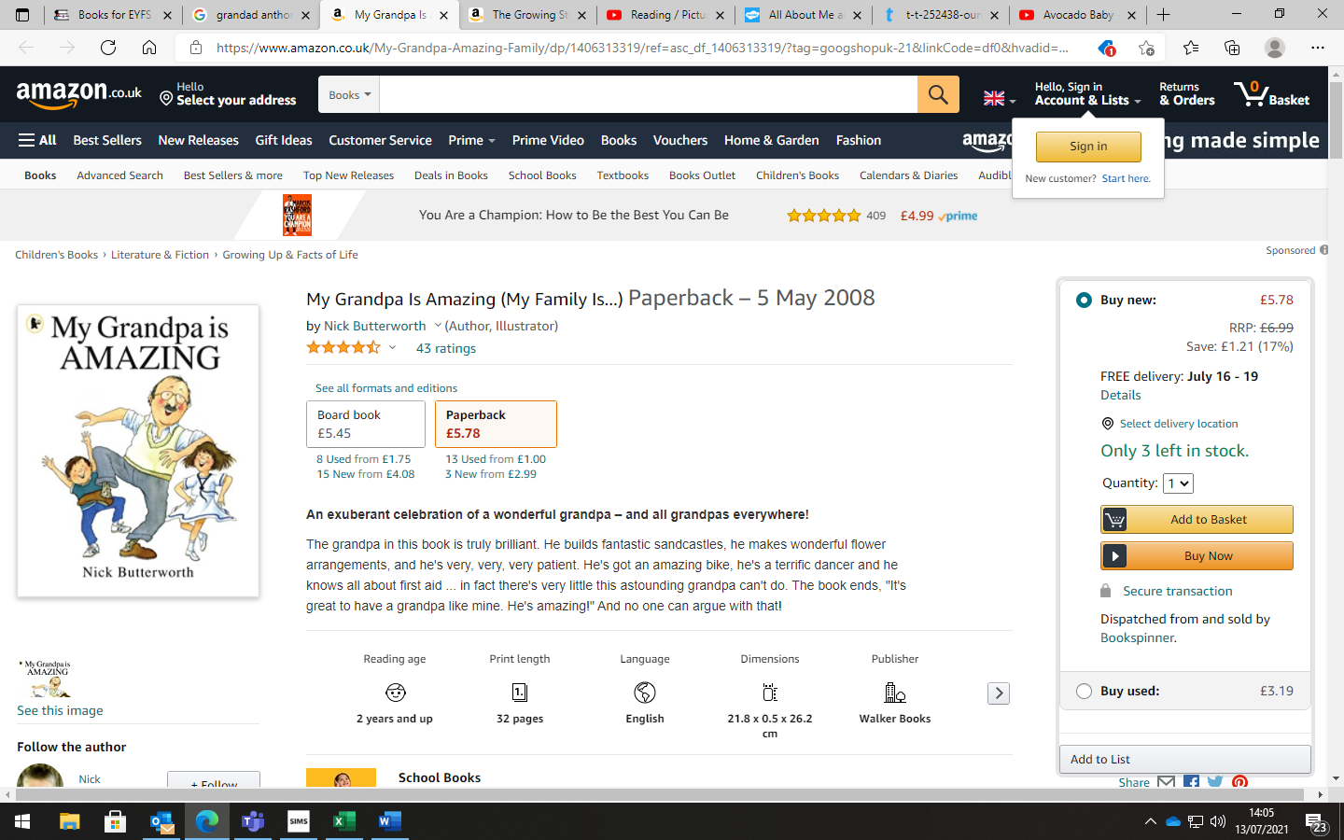  Role play – police station – mark making and adding meaning to our marks – writing incident reports. | 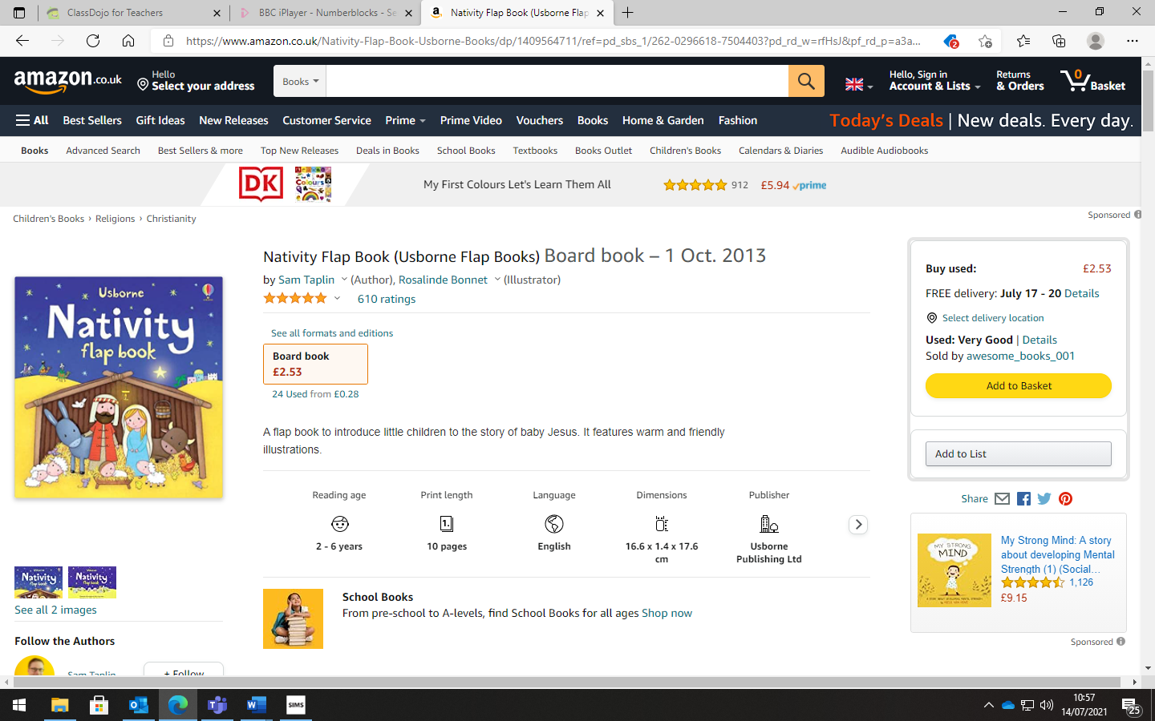  Role play – being Santa’s helper preparing the present list.  Giving meaning to marks – writing instructions for wrapping presents. |  | 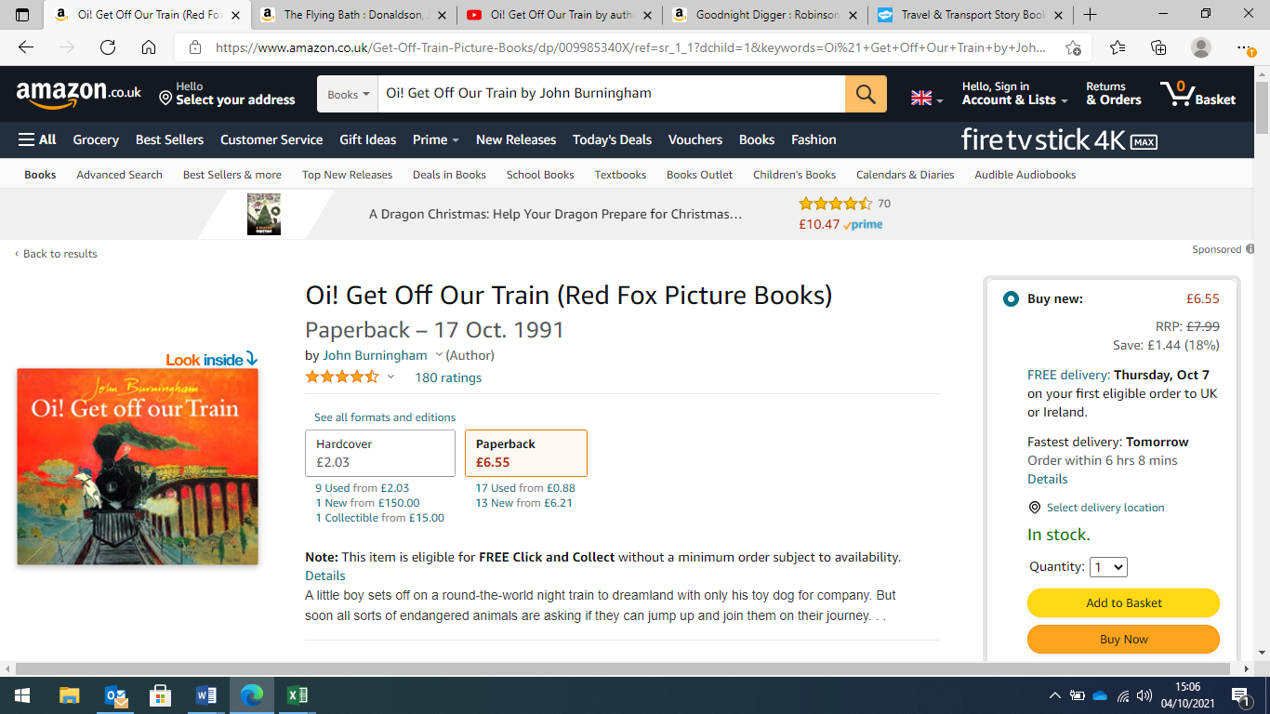  Role play – pretending to be the train conductor recording how many passengers are on the train. |  | 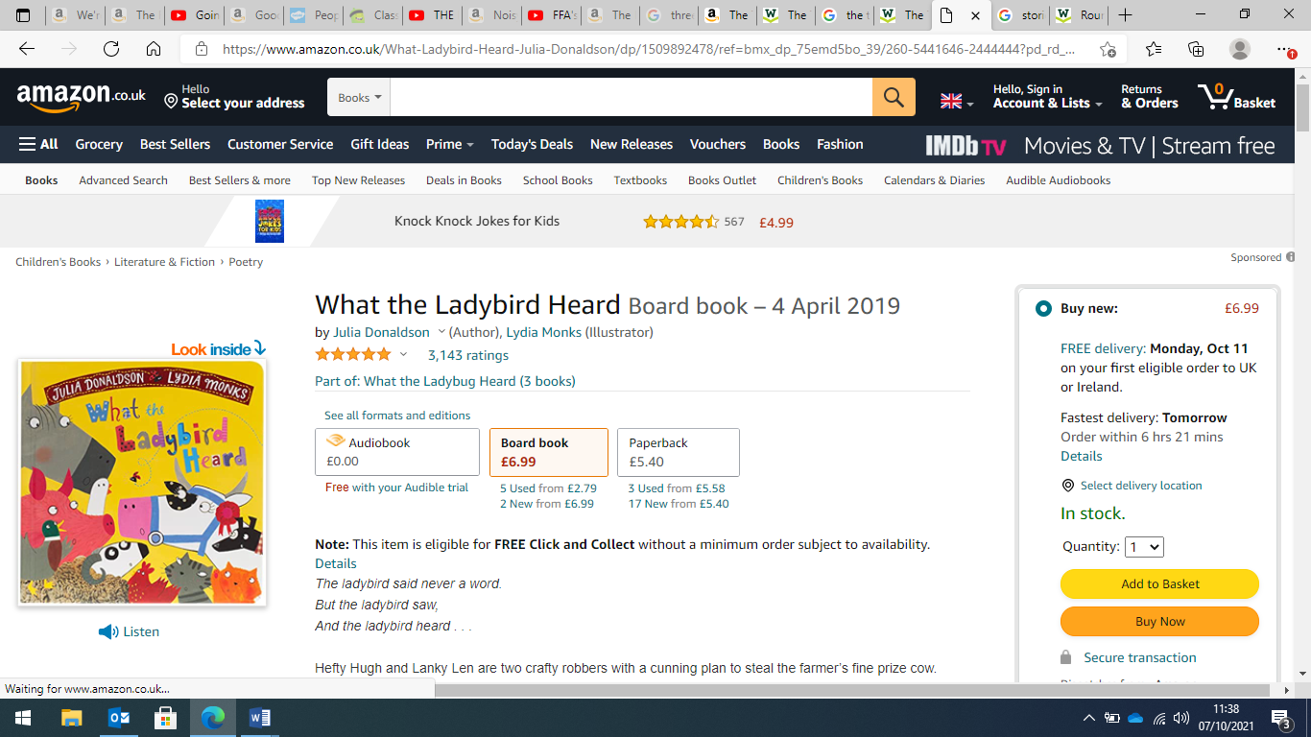  Giving meaning to marks – create a map of the farm and add labels to what they have drawn. |  | 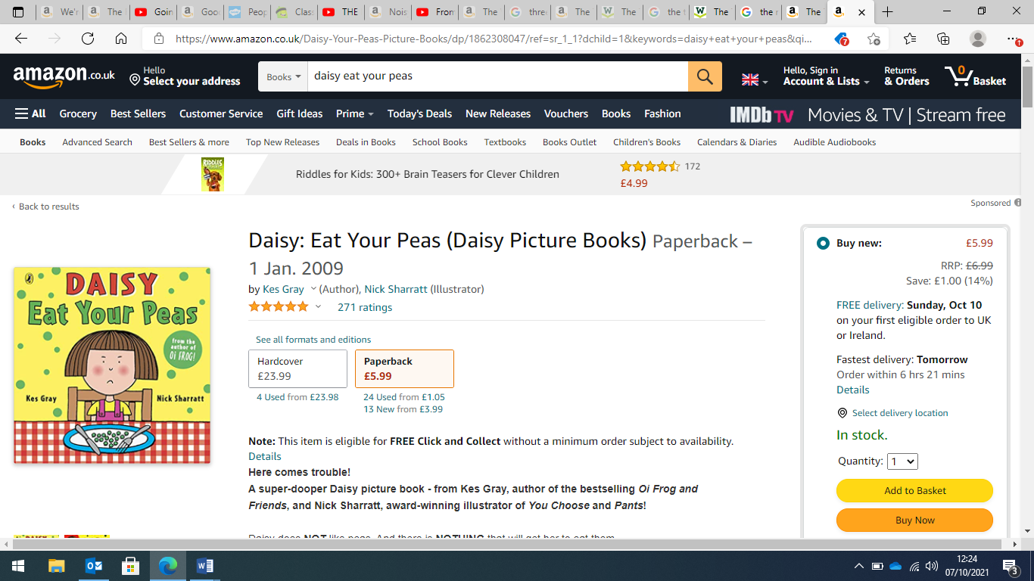  Mark making – giving meaning to marks – create a list of things they would use to persuade some to eat something they don’t like. |  | 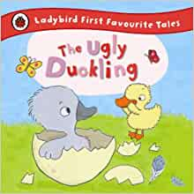
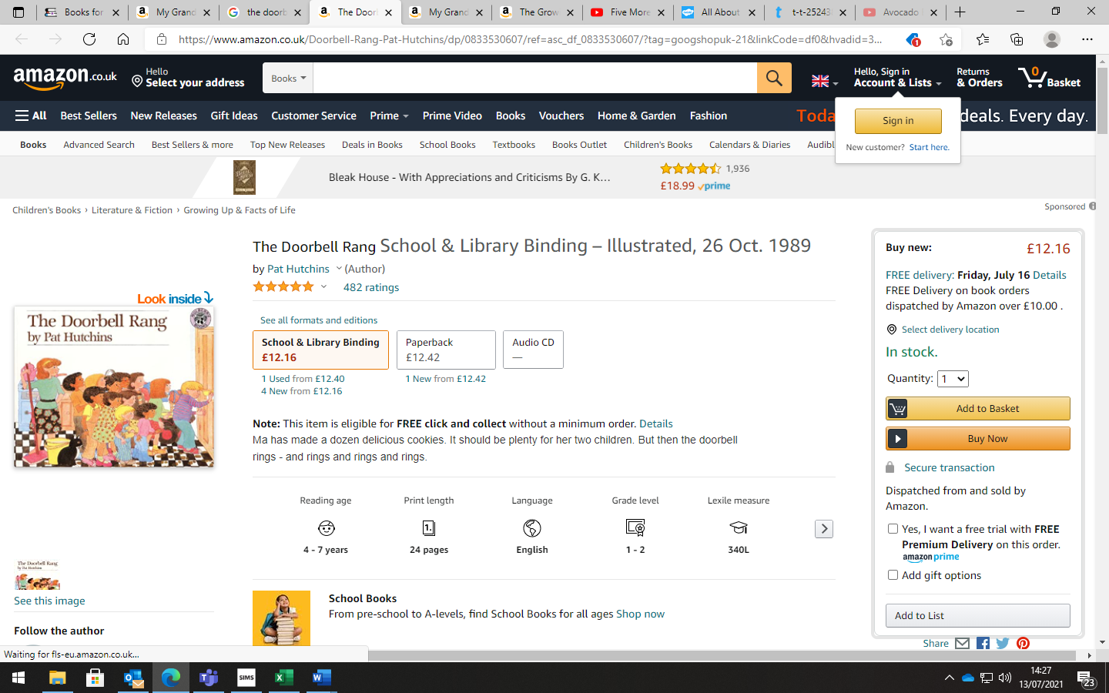  Adding meanings to our marks – creating a recipe to follow when baking cookies. | 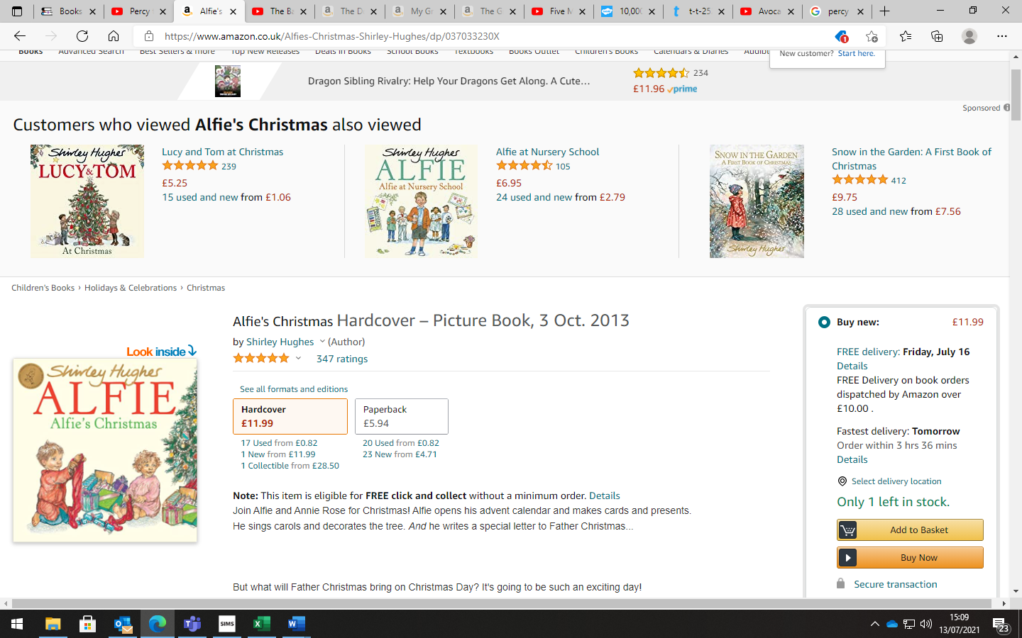  Mark making – creating patterns as if they were skating on ice – circles, spirals, lines etc. |  | 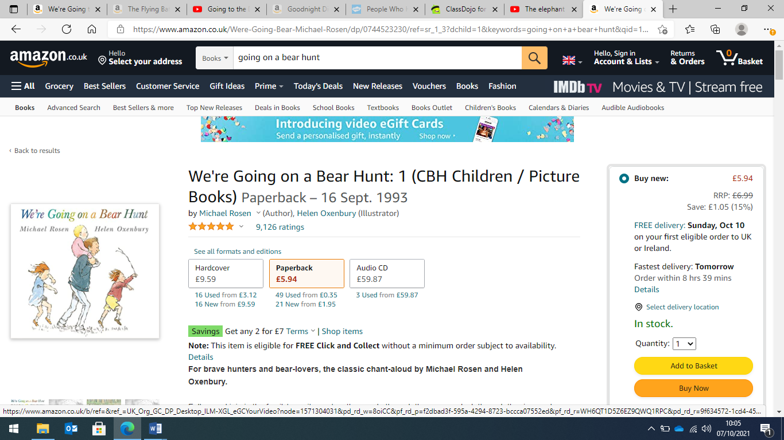  Mark making – creating a map of the garden for the children to follow. |  |  |  |  |  | 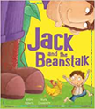
Additional Storytime Reads
These stories are read to the children again and again, throughout the year. Through listening to repeated readings, and talking about what they have heard, the children have multiple exposures to vocabulary and the language of stories. Continued talk about words, as well as opportunities to use them, helps our children to become increasingly familiar with the language found within its pages. Through stories, our children encounter vocabulary that they may not hear in everyday conversation but will come across in writing, once they can read for themselves.
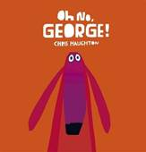 |  | 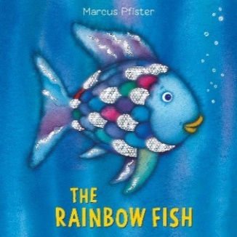 |  | 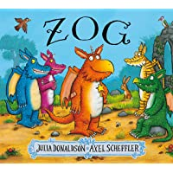 |  | 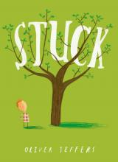 |  | 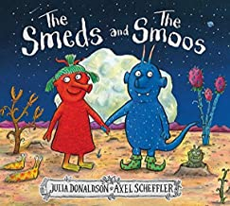
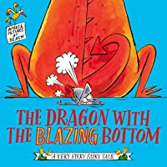 |  | 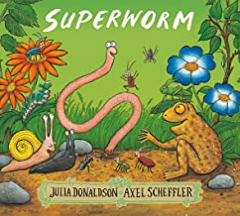 |  | 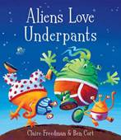 |  | 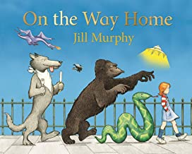 |  | 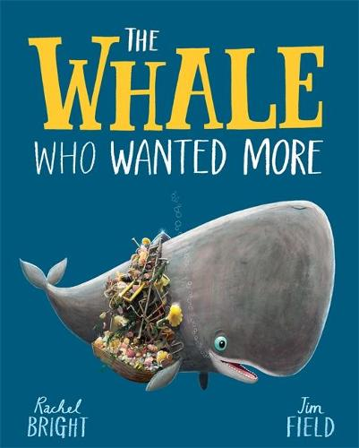
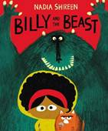 |  | 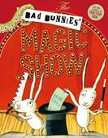 |  | 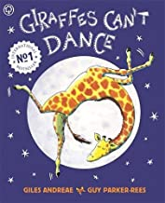 |  | 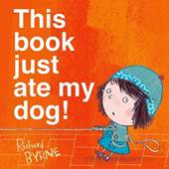 |  | 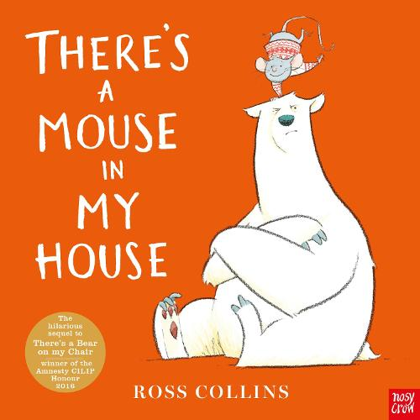
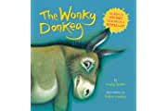 |  | 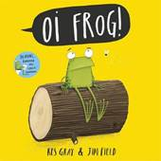 |  | 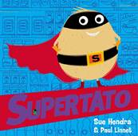 |  | 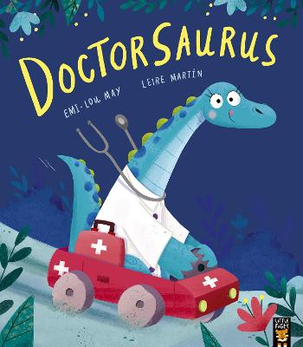 |  | 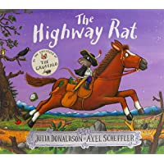
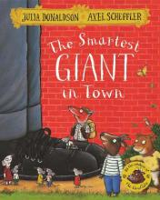 |  | 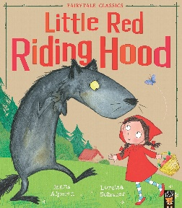 |  | 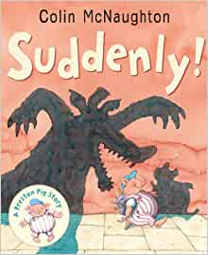 |  | 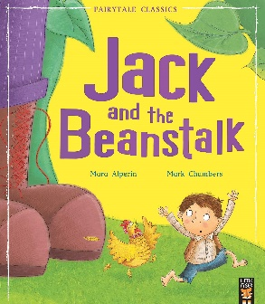 |  | 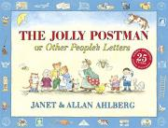
Daily Song, Rhyme and Poetry Time
Daily songs and nursery rhyme times are another important part of the day for our youngest children in school. Through enjoying rhymes, poems and songs, and reciting poems or parts of longer poems together as a class, we build our children’s strong emotional connection to language.
By learning poetry and songs using ‘call and response’, we enable our children to join in gradually. Each repetition strengthens their vocabulary, embedding new words.
Head, shoulders, knees and toes.  Hey diddle diddle.  Here we go around the mulberry bush.  Little Miss Muffet  Miss Polly  Wind the bobbin up | 1,2,3,4,5 once I caught a fish alive.  Teddy bear, Teddy Bear  5 speckled frogs  5 Little Monkeys  5 little men in a flying saucer  5 little ducks

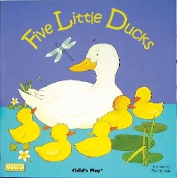
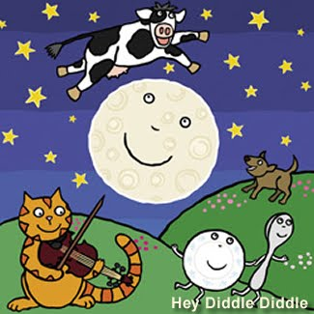

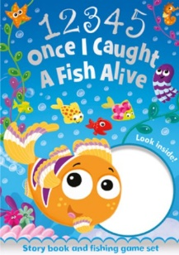
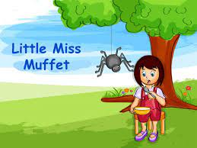
The Daily Poem
At Captain Webb Primary, we believe it is important to set aside 5 minutes every day to listen to and enjoy Poetry.
The Poetry Spine is a core of books that foster a love of poetry with the best children's anthologies, hand-picked by literacy expert Pie Corbett.

