Reading
Autumn 1 |  | Autumn 2 | Spring 1 | Spring 2 | Summer 1 | Summer 2
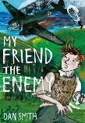  My Friend the Enemy  By Dan Smith |  | 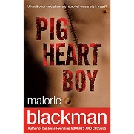  Pig Heart Boy  by Malorie Blackman | 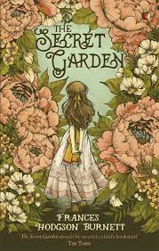  The Secret Garden by Frances Hodgson Burnett | 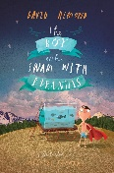  The boy who swam with the piranhas by David Almond | 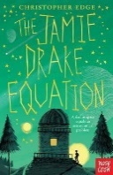  The Jamie Drake Equation by Christopher Edge | 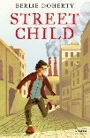  Street Child by Berlie Doherty.
WW2 Non Fiction Texts |  | Ancient Egypt Non Fiction Texts | Mini Beasts Non Fiction Texts | Forces Non Fiction Texts | Space Non Fiction Texts | The Victorians Non Fiction Texts
Writing
 | Autumn 2  RAF Cosford | Autumn 1  Egyptians | Spring 1  Beast Creator | Spring 2  Theme Park | Summer 1  Stargazers | Summer 2  Blists Hill
Quality Text/ Stimulus | Radio Broadcasts WWII  My friend, the enemy by Dan Smith  Carries War by Nina Baldwin  Goodnight Mister Tom by Michelle Magorian  War Horse by Michael Morpurgo | Pig Heart Boy by Malorie Blackman | Tom’s Midnight Garden by Phillipa Pearce | The London Eye Mystery  Siobhan Dowd  Alice in Wonderland by Lewis Carroll  Alice through the Looking glass by Lewis Carroll.  Thief by Malorie Blackman | Phoenix by S F Said  Cosmic by Frank Cotterell Boyce  Jamie Drake Equation by Christopher Edge | Street Child Berlie Doherty  Oliver Twist by Charles Dickens  Gaslight by Eloise Williams
Purpose for Writing  Text Type | To Inform  Newspaper Report x 2wks  To Entertain  Narrative x3wks – Alternative chapter  Historical / Moral Dilemma  To Entertain  Poetry x 1wk Personification | To Entertain  Diary Entry x 3wks  To Inform  Non Chronological Report x 2 wks *River Nile | To Entertain  Narrative x 3wks  Fantasy  To Persuade  Holiday Brochure Advert x 2 wks  To Entertain  Poetry x 1 wk  Cinquain | To Entertain  Narrative x 3wks  Adventure/ Mystery  Portal Story  To Persuade  Persuasive leaflet x2wks  To Entertain  Poetry x 1wk  Blackout Poetry | To Entertain  Narrative x 2 wks Science Fiction Quest Story  To Discuss  Should we be travelling to Space? 2 wks | To Entertain  Narrative x 3 wks Historical  Pie Shop  To Inform  Formal Letter x 2 wks  *Silkin Way
Oracy Projects | Class Assembly | Performance Poetry: Christmas | Performance Poetry: Chester Zoo  Debate: The Rainforest | World Poetry Day performances  Debate: Should we build a theme park on Telford town park? | Debate: Space Exploration | End of Year Performance  Debate: Silkin Way.
Performance Poetry |  | Cats by Eleanor Farjeon | Tyger by William Blake |  |  | The Railway Carriage by Robert Louis Stevenson
National / World Events  *Purposeful writing & speaking and listening opportunities | National Poetry Day  Black History Month |  | National Storytelling Week | International Women’s Day  World Book Day  World Storytelling & Poetry Day | World Day for Cultural Diversity | World Environment Day
Story Time Texts | 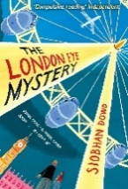  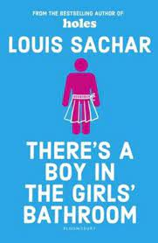  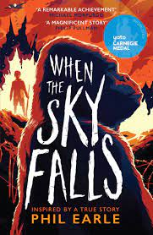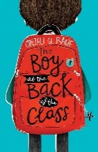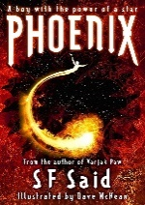
Poetry  Pie Corbett’s Year 5 Spine  Daily Poem | 