TOPIC | Healthy Me! | Wriggle and Crawl | London |  | Scented Garden | Land Ahoy!
Writing | Autumn 1 | Autumn 2 | Spring 1 | Spring 2 | Summer 1 | Summer 2
Quality Text/  Stimulus | Author Focus  Vivian French  *Oliver’s Milkshake *Oliver’s Fruit Salad  *Oliver’s Vegetables  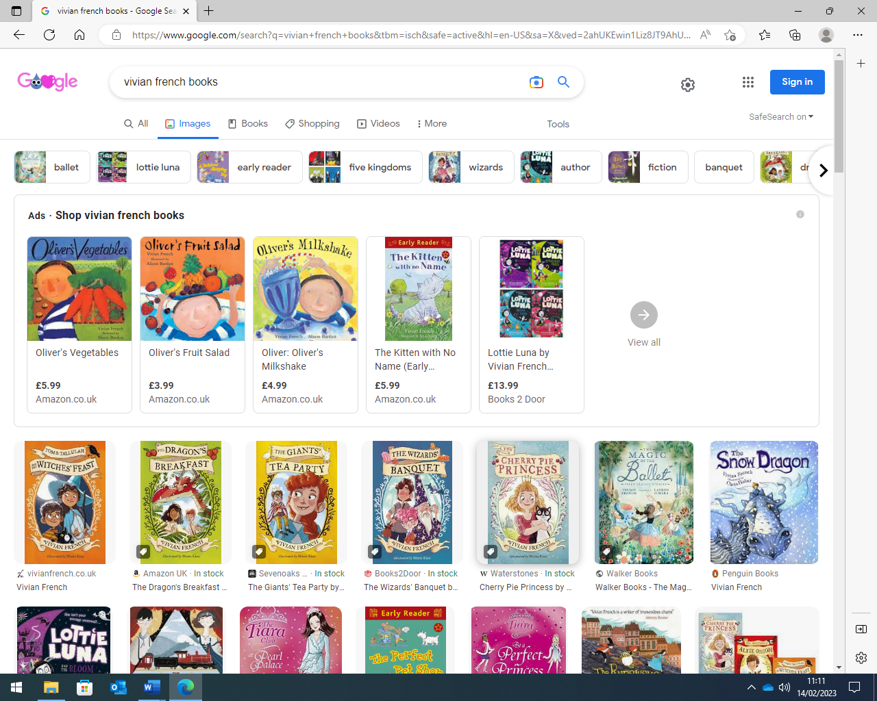  Healthy Living Non Fiction Books  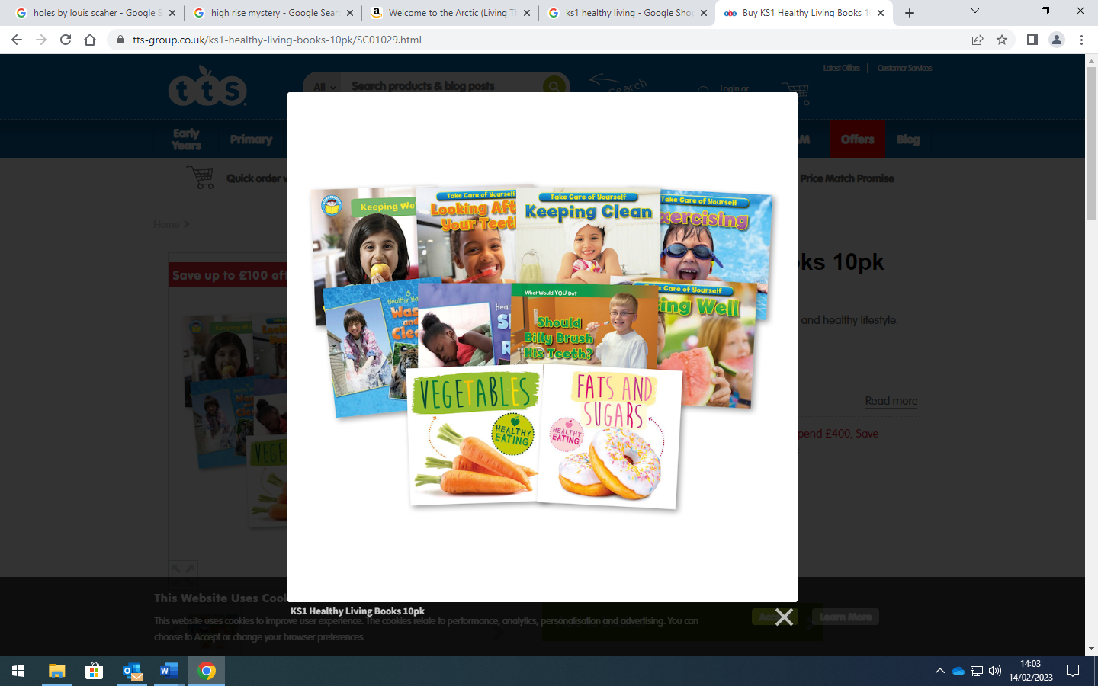 | The Woolly Bear Caterpillar by Julia Donaldson  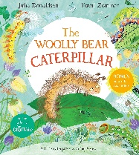  Habitat Non-Fiction Books  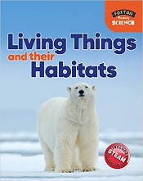 | Coming to England by Floella Benjamin.  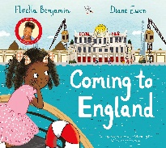  Poem: Buckingham Palace by AA Milne  Katie in London by James Mayhew  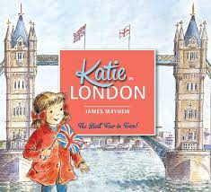 | On the way home by Jill Murphy  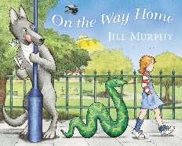  Great Fire of London by Susanna Davidson  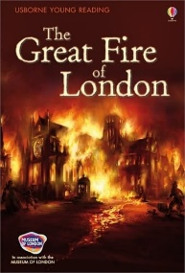 | Jack and the Beanstalk  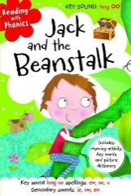  Plant Non Fiction Books  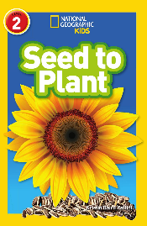  Diamante Poetry | The Lighthouse Keepers Lunch by David and Ronda Armitage  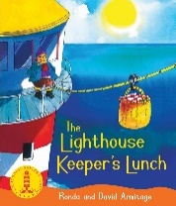  Grace Darling  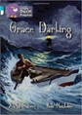  Dragon Post by Emma Yarlett  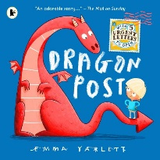  Poems with alliteration
Purpose for Writing  Text Type | To Entertain  Narrative x 3 wks  To Inform  Instructions x 1 wk  Visit: Workshop  To Inform  Non Chronological Report x 2 wk | To Entertain  Narrative x 3 wks  Visit: Dudley Zoo  To Inform  Non Chronological Report 2wks | To Entertain  Narrative x 2 wks  Visit: London  To Inform  Explanation x 2 wks (London Boat Guide)  To Entertain  Poetry: Quatrain (Rhyming Couplets) x 1 wk | To Entertain  Narrative x 2 wk  To Entertain  Diary Entry x 2wks  *Plants  To Inform  Instructions 1 wk | To Entertain  Poetry: Diamate x1 wk  Visit: Dorothy Clive  To Inform  Recount x 1wk  To Entertain  Narrative x 2 wks | To Entertain  Narrative 2 wks  Visit: Beach  To Inform  Letter 1 wk  To Entertain  Poetry: Alliteration x 1wk  To Inform  Sports Day Commentary
Oracy Projects | Record Instructions | Christmas Production  Poetry performance | Class Assembly | Record Diary Entries  Poetry Performance | Diamante Poetry Read | Alliteration Poetry Read
Performance Poetry | Peter Piper by John Harris  To be performed on NationaL Poetry Day |  | Buckingham Palace  By AA Milne  To be performed in the class assemblies. | Owl and the Pussycat by Edward Lear  To be performed on World Poetry Day
National / World Events  *Purposeful writing & speaking and listening opportunities | National Poetry Day  Black History Month |  | National Storytelling Week | International Women’s Day  World Book Day  World Storytelling & Poetry Day | World Day for Cultural Diversity | World Environment Day
Story Time Texts  *Rich vocabulary development  *Emotional Literacy  *Diversity  *Environmental conservation  *Poetry | The true story of the three little pigs by John Scieszka  Don’t look in this book by Samuel Langley – Swain  The Dot by Peter H. Reynolds PSED  Mr Wolf’s Pancake by Jan Fearnley  Revolting Recipes by Roald Dahl  Tuesday by David Wisener  A planet full of plastic by Neal Layton Environment and Sustainability  Captain Cooks Favourite Books by Julia Donaldson  The great paper caper by Oliver Jeffers Environment and Sustainability  The colour monster by Anna Llenas PSED  Green eggs and ham by Dr Seuss.  How to live forever by Colin Thompson  Every Night is Pizza Night by J. Kenji López-alt and Gianna Ruggiero  Ready, Steady Mo! by Mo Farah (Black History Month)  The Way Back Home by Oliver Jeffers  Oi Dog! By Kes Gray & Jim Field  Isabel’s Nopisy Tummy by David McKee  18  Non Fiction  Healthy lifestyle books | The Bear and the Piano by David Lichfield  The whale who wanted more by Rachel Bright Environment and Sustainability  Twist and hop minibeast bop by Tony Mitton  The koala who could by Rachel Bright  The Enormous Crocodile by Roald Dahl  Spinderella by Julia Donaldson  Spyder by Matt Carr  Mad about Minibeasts by Giles Andreae  Dora’s Egg by Julie Sykes  The Hodgeheg by Dick King Smith  Hello great big bullfrog by Colin West  Hello! Hello! Matthew Cordell PSED: Online Safety  Billy and the Beast by Nadia Shireen Diversity  Flat Stanley by Jeff Brown  Tadpoles Promise by Jeannie Willis and Tony Ross  Slowly, Slowly, Slowly went the Sloth by Eric Carle  Oi Frog! By Kes Gray & Jim Field  The Selfish Crocodile by Faustin Charles and Micheal Terry  19  Non Fiction  Living things and their habitats | Rapunzel – First Readers  Paddington at the Tower by Michael Bond  The Paper Bag Princess by Robert Munsch & Michael Martchenko Environment and Sustainability  I can catch the monster By Bethan Woolvin PSED  Small knight and George and the Chocolate Cake by Ronda Armitage  Emily Brown and the Thing by Cressida Cowell  The Princess and the Wizard by Julia Donaldson  Troll Stinks! By Jeanne Willis & Tony Ross PSED  The knight that wouldn’t fight by Helen Docherty  The Dragon Machine by Helen Ward  Again by Emily Gravett  Good knight, Bad Knight by Tom Knight.  Billy and the Dragon by Nadia Shireen Diversity  The last wolf by Mini Grey Environment and Sustainability  The Dog Detectives Lost in London by Zoa Gypsy  Alladin and the Enchanted Lamp by Philip Pullman  17  Non Fiction  Geography: Telford, Trinidad  Continents and Oceans | Jinnie Ghost by Berlie Doherty PSED  The Queen’s hat by Steve Anthony  Paddington at the Palace by Michael Bond  The Tale of the Castle Mice by Michael Bond  The Egg by M. P. Robertson  Clean Up! By Nathan Byron Cultural Diversity & Environment and Sustainability  Voices in the Park by Anthony Browne.  The Tunnel by Anthony Browne  The Proudest Blue: A Story of Hijab and Family by Ibtihaj Muhammad  Through the magic mirror by Anthony Browne  Speak Up! By Nathan Byran Diversity  See what I can do! By Jon Roberts  Our Tower by Joseph Coelho  Don’t ask the Dragon by Lemn Sissay  What We’ll Build by Oliver Jeffers  Up and Down by Oliver Jeffers  Cleverstciks by Bernard Ashley  Diversity  The Huge Bag of Worries by Virginia Ironside PSED  Rapunzel – Bethan Woollvin  18  Non Fiction  History: The Great Fire of London  Monarchy | The flower by John Light  A Tiny Seed by Eric Carle  Peter Rabbit by Beatrix Potter  The Heart and the Bottle by Oliver Jeffers PSED  The Secret Garden by Claire Freedman  The Extraordinary Gardener by Sam Boughton  Tidy by Emily Gravett Environment and Sustainability  Sams Duck by Michael Morpurgo PSED  Lila and the secret rain by David Conway  Diversity PSED  Jack and the Baked Bean Stalk by Colin Stimpson  Jack and the Jelly Bean Stalk by Rachael Mortimer  Jim and the Beanstalk by Raymond Briggs  The stinky cheese man and other fairy tales by Jon Scieszka  Hansel and Gretel by Bethan Woollvin  Kasia’s Surprise by Stella Gurney  Blue Penguin by Petr Horacek  Jack and the Beanstalk by M&S First Readers  Sunflower Sisters by Monkia Singh  Cultural Diversity  18  Non Fiction  Plants  Hot and Cold places in the world | Captain Flinn and the Pirate Dinosaurs by Giles Andrae  Salty Dogs by Matty Long  Grandads Island by Benji Davies PSED  Pirate School: Just a bit of wind by Jeremy Strong  Somebody swallowed Stanley by Sarah Roberts Environment and Sustainability  Flotsam by David Wiesner  Commotion in the Ocean by Giles Andreae  Snail and the Whale /  Sharing a Shell/  Tiddler by Julia Donaldson  A Hole in the Bottom of the Sea by Jessica Law  The Storm Whale by Benji Davies Environment and Sustainability  Port Side Pirates by Debbie Harter  Winnie and Wilbur at the Seaside by  Lucy and Tom at the seaside by Shirley Hughes  The Lighthouse Keeper’s Rescue by Ronda and David Armitage  The Lighthouse Keeper’s Picnic by Ronda and David Armitage  The Lighthouse Keeper’s Tea by Ronda and David Armitage  The Big Big Sea by Martin Waddell T`TY`  Billy and the Pirates by Nadia Shireen Diversity  Pirates Love Underpants by Claire Freedman  The Magic Finger by Roald Dahl  Pirates Moms by Jodie Lancet Grant Diversity  Nen and the Lonely Fisherman by Ian Eagleton and Jamnes Mayhew  Non Fiction  Grace Darling Non Fiction  Seaside Non Fiction
Poetry  Pie Corbett’s Year 2 Spine  Daily Poem | 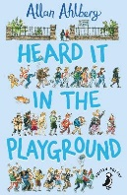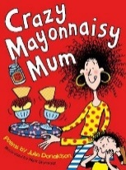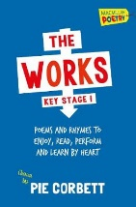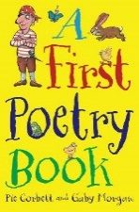

Guided Reading  Fiction | All children take part in daily guided reading lessons that focus on promoting pupil’s phonics knowledge and decoding at word level, reading for enjoyment, developing reading stamina, and exploring texts to improve comprehension skills. Children are engaged in reading a variety of carefully selected books within a group setting. We assess the pupils using the SALFORD Reading Test, all pupils are assigned a particular book, matched to their reading age and ability.  Here are a selection of books your child will read this year in their Guided Reading sessions.
 | 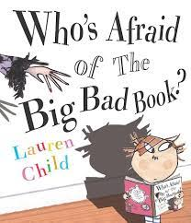  Who’s afraid of the big bad book? By Lauren Child | 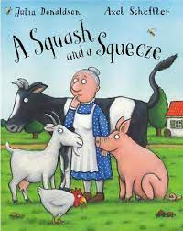  A squash and a squeeze by Julia Donaldson | 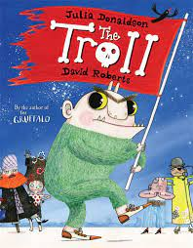  The Troll by Julia Donaldson | 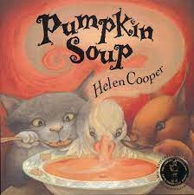  Pumpkin soup by Helen Cooper | 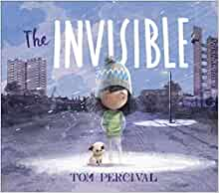  The invisible by Tom Percival | 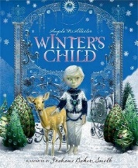  Winters child by Angela McAllister | 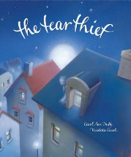  The tear thief by Carol Ann Duffy | 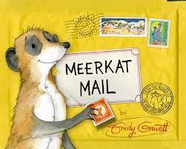  Meerkat mail by Emily Gravett | 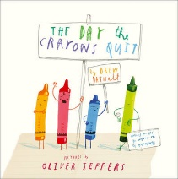  The day the crayons quit by Oliver Jeffers
 | 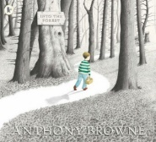  Into the forest by Anthony Browne | 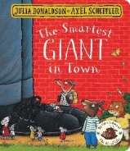  The smartest giant in town by Julia Donaldson | 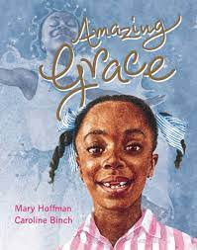  Amazing Grace by Mary Hoffman | 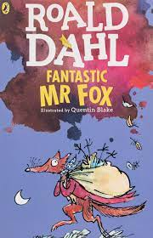  Fantastic Mr Fox by Roald Dahl | 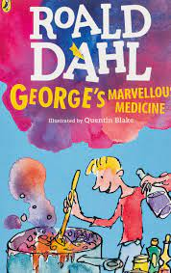  George’s marvellous medicine by Roald Dahl | 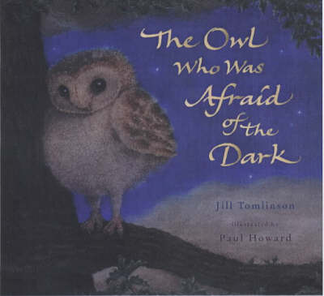  The owl who was afraid of the dark by Jill Tomlinson | 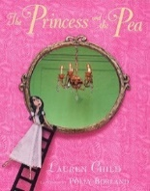  The princess and the pea by Lauren Child | 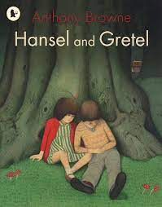  Hansel and Gretal by Antony Browne | 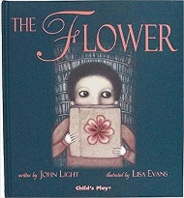  The flower by John Light
 | 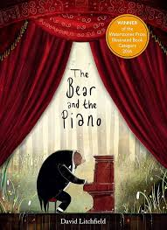  The Bear and the Piano by David Litchfield | 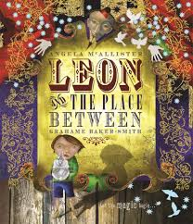 Leon and the place between by Angela McCalister | 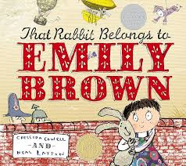  That rabbit belongs to Emily Brown by Cressida Cowell | 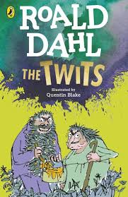  The twits by Roald Dahl
Non Fiction | 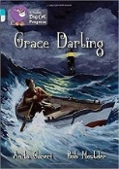 | 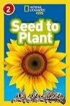 | 