Reading
Autumn 1 |  | Autumn 2 | Spring 1 | Spring 2 | Summer 1 | Summer 2
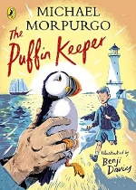  The Puffin Keeper  by Michael Morpurgo |  | 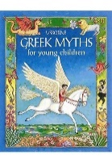  Greek Myths for Young Children by Usborne Books | 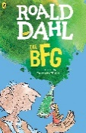  The BFG by Roald Dahl | 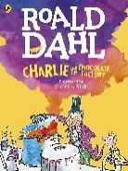  Charlie and the Chocolate Factory by Roald Dahl | 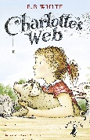  Charlottes Web by E B White | 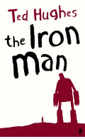  The Iron Man by Ted Hughes
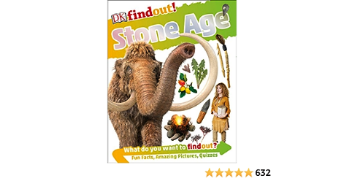  DK: Stone Age (Non Fiction) |  | 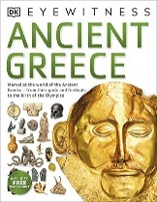  DK: Ancient Greece  (Non Fiction) | 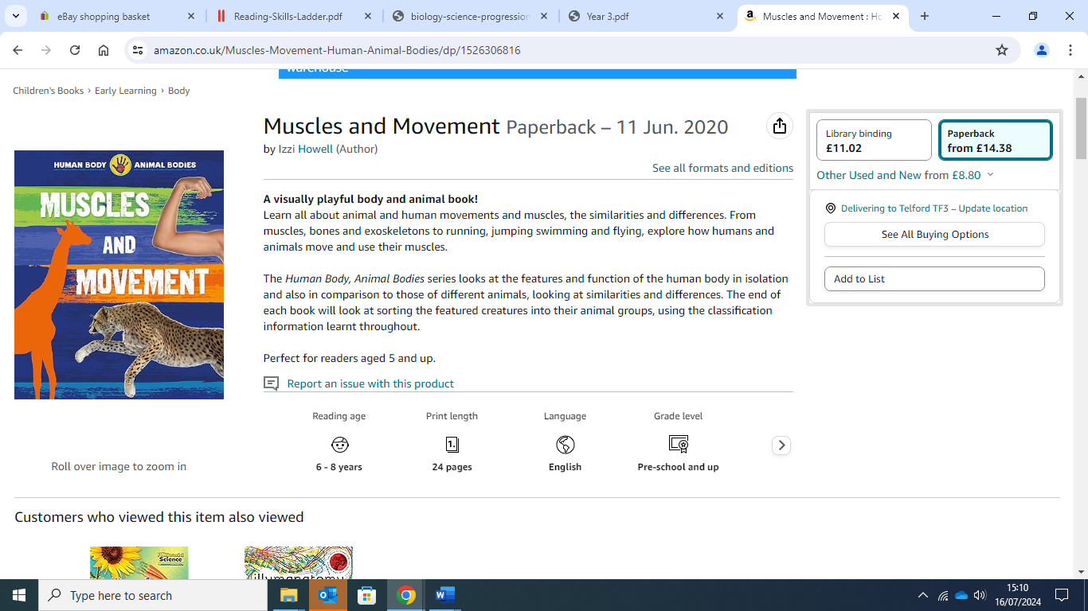  Muscles and movement- (Izzi Howell) | 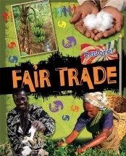  Fair Trade | 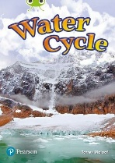  Water Cycle (Non Fiction) | 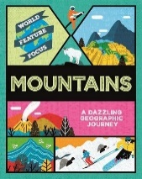  Mountains (Non Fiction)
Writing
 | Autumn 1  Stone Age | Autumn 2  Ancient Greece | Spring 1  My Telford | Spring 2  Scummdiddlyumtious! | Summer 1  Rivers | Summer 2  Mountains
Quality Text/ Stimulus | Stone Age Boy by Satoshi Kitamura  Stone Age Non Fiction texts. (DK series) | Greek Myths for Young Children | The Wellington Cobbler and The Wrekin Giant by Dave Weston  Shropshire Folk Tales by Amy Douglas | Charlie and the Chocolate Factory by Roald Dahl  Fair Trade (Explore!) – Jillian Powel  Beans to Chocolate – Sarah Ridley | Charlottes Webb by E B White  Water Cycle Non Fiction Text by Torrey Maloof  (Bug Club) | The Iron Man by Ted Hughes  Mountains by Rebecca Kahn
Purpose for Writing  Text Type | To Entertain  Narrative: Adventure Portal Story  To Inform  Non Chronological Report  To Entertain  Poetry: Alliteration and similes | To Entertain  Narrative: Myth  To Inform  Letter  To Entertain  Poetry: Haiku / Tanka | To Entertain  Narrative: Shropshire Based Myth  To Persuade  Advert | To Entertain  Narrative: Fantasy  To Inform  Newspaper Report  To Entertain  Poetry: Acrostic Poems | To Entertain  Narrative: Adventure  To Inform  Explanation | To Entertain  Diary Entry: Science Fiction  To Inform  Non Chronological Report
Oracy Projects | Sharing Stories with KS1 | Christmas Concert | Recorded Advert | World Poetry Day performance | Record Explanation | Perform Poems
Performance Poetry |  | Twas the night before Christmas by Clement Clarke Moore  To be performed in the Christmas Carol Service |  | Chocolate Cake by Michael Rosen  To be performed for World Poetry Day. | Ning, Nang, Nong by Spike Milligan  To be performed in the class assemblies
National / World Events  *Purposeful writing & speaking and listening opportunities | National Poetry Day  Black History Month |  | National Storytelling Week | International Women’s Day  World Book Day  World Storytelling & Poetry Day | World Day for Cultural Diversity | World Environment Day
Story Time Texts | 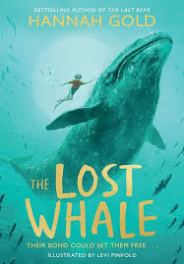  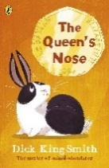  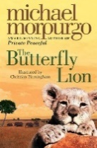  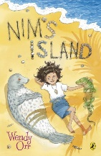  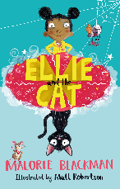
Poetry  Pie Corbett’s Year 3 Spine  Daily Poem | 